|  |  |
| --- | --- |
| Reason: | Operatives should be aware of the hazards associated when welding in particular fume control, general ventilation LEV & PPE. |
| Outline: | This talk covers the hazards associated when welding and any toxic fumes produced during the process. |

|  |
| --- |
| Hazards: |

1. Confined space welding – lack of oxygen. Inert gases & chemical reactions can reduce the amount of oxygen inside enclosed spaces such as tanks, pipes & pits.

2. preventing fire and explosion. A clean workspace free from obstruction and particularly flammable materials and substances. Fire watches to be employed for a minimum of 1 hour following any hot works.

3. Electrical hazards – The arc welding process requires a live electrical circuit and are therefore at risk of electric shock & electrical burns. PPE, regular equipment inspections and cleans are essential to reduce risks.

4. Welding fume (which includes irritating gases such as oxides of nitrogen and ozone) may cause respiratory irritation and metal fume fever. It can also increase susceptibility to pneumonia. Long term serious lung diseases, occupational asthma, cancer & COPD. May also cause adverse neurological effects resultant from exposure to manganese, ubiquitous in mild steels, some stainless steels and welding consumables.

2. Shielding gases (such as argon, helium and nitrogen, or argon-based mixtures containing carbon dioxide, oxygen, or both) can cause asphyxiation 9suffocation from lack of oxygen), usually resulting from accumulation of the gases in confined spaces and/or displacement of the oxygen.

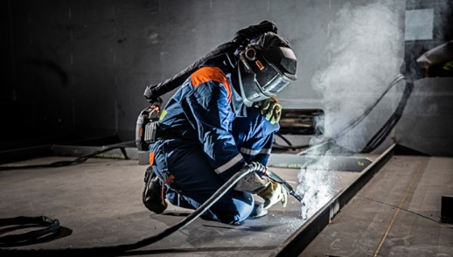

|  |
| --- |
| Health Risks: |

**Acute Respiratory** health effects occur quite soon after exposure to welding fume. Irritation to the throat and larger airways in the lungs. Acute irritant-induced asthma. Metal fume fever. Acute pneumonia.

**Chronic Respiratory** Health effects develop more gradually after exposure and result in more serious diseases. Lung cancer. Chronic obstructive pulmonary disease (COPD). Welders’ lung. Occupational Asthma.

**Asphyxiation** when welding in a confined space.

Other effects are; Skin effects, Neurological effects, Ocular melanoma, Arc-eye, Noise and Vibration.

|  |
| --- |
| Precautions: |

❶Design the job so less welding is required – cold joining techniques, mechanical fasteners, or adhesives.

❷Remove grease and all surface coatings first, paint and resin coatings may release toxic components when heated.

❸Position the workplace and LEV (local exhaust ventilation) hood to reduce the worker being exposed to rising fumes.

❹When welding outside, LEV is usually not practical, use RPE as a suitable alternative.

|  |
| --- |
| Local Exhaust Ventilation: |

Ensure the most appropriate extraction design is chosen for the welding purpose.

Design of the hood is particularly important as it is the air inlet into the LEV system determines the effectiveness of the system.

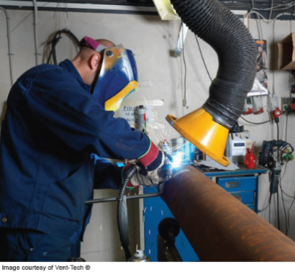 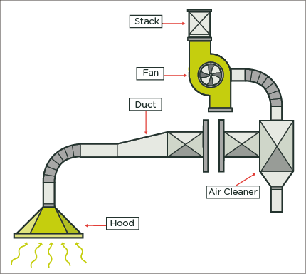

Provide an easy way of checking the LEV is working, e.g., airflow indicator.

Ensure extracted air is discharged outside the building to a safe place away from doors, windows, and air inlets. Where not possible – Air extracted needs to be cleaned, filtered. – use suitable filters within the unit & replaced regularly.

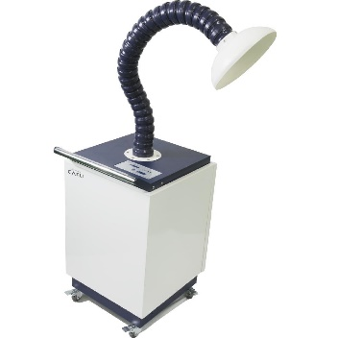

Portable LEV. – Workpieces that can be transported to a workplace and positioned on a welding bench or booth.

Ensure the fumes are drawn away from the welder enclosing as much of the bench as possible.

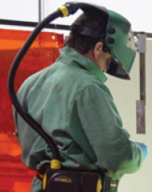

**Discussion Points:**

What different types of LEV are available? Where are they most effective?

RPE – where should it be used?