|  |  |
| --- | --- |
| Reason: | Operatives should be aware of the hazards associated with the erection of steelwork. This potentially dangerous activity poses risks to safety of those erecting the steelwork and to others who are in the vicinity. |
| Outline: | This talk covers the hazards associated with the erection of steelwork and the precautions required. |

|  |
| --- |
| Hazards: |

1. Falls from height are a common source of serious and fatal injuries in the construction industry. Ensure that you are never at risk of falling.

2. Falling tools and materials are a hazard to others when you are working at height.

3. Electrocution from live overhead electrical cables may be a hazard.

4. There is always a danger of impact injuries, including head injuries, when beams are being lifted.

5. if MEWPs or other access equipment is to be used, the ground conditions must be suitable. The operator should also have a lift plan.

6. operators and others in the basket of a cherry picker must wear a harness and restraint lanyard clipped to the machines designated anchorage point.

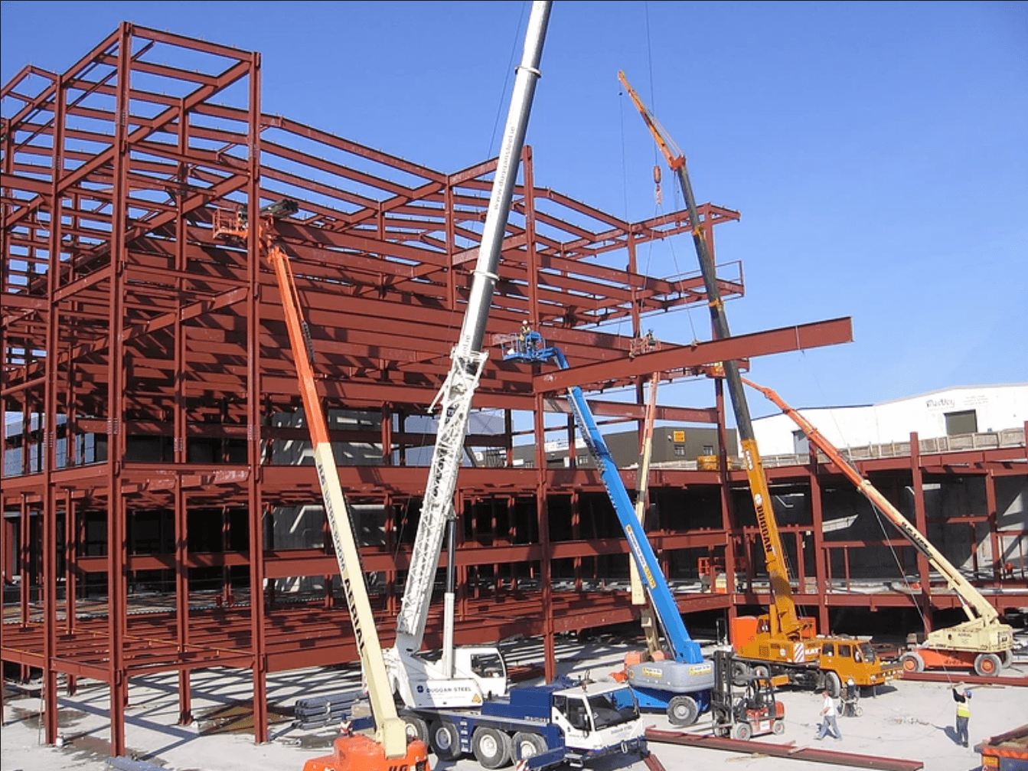

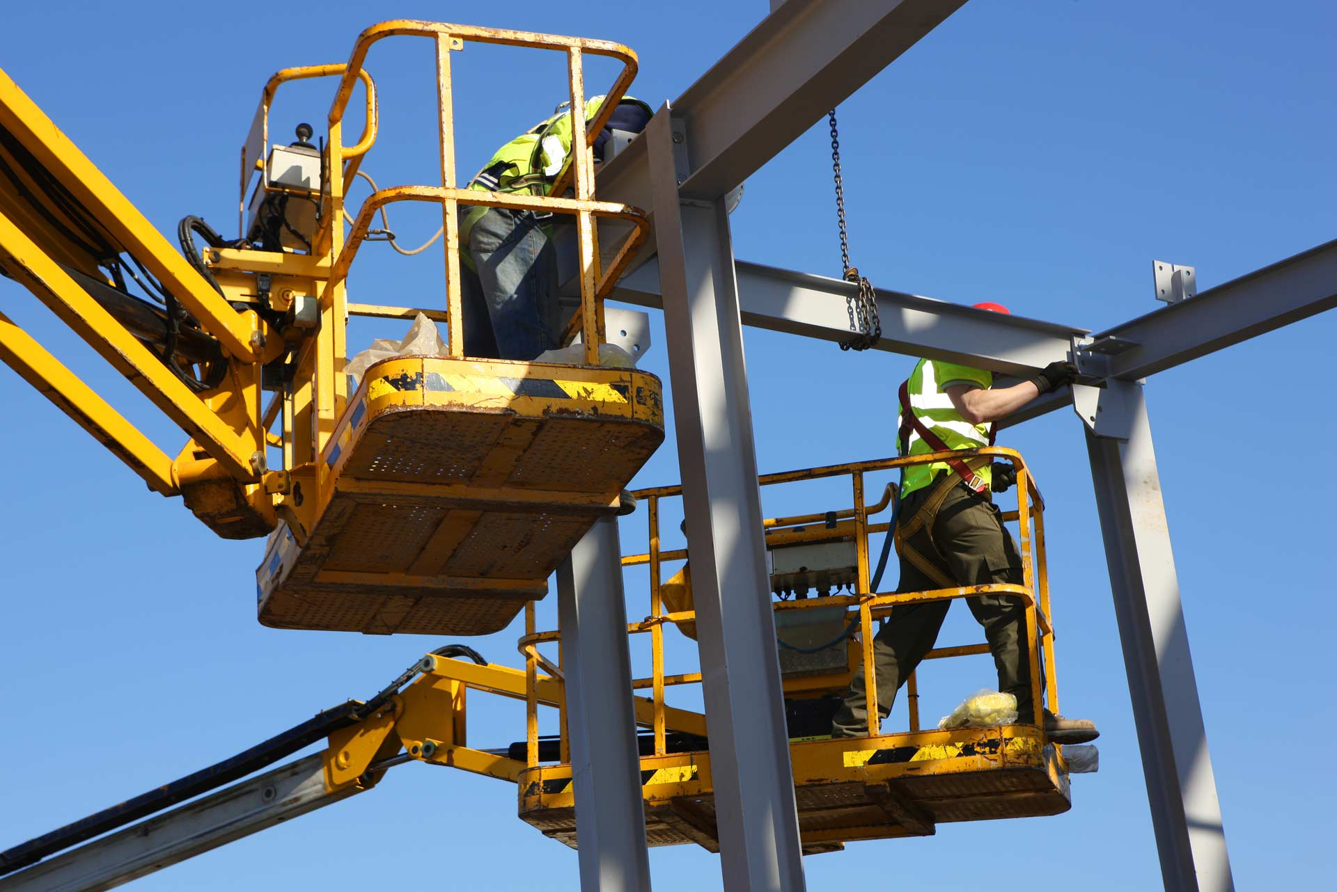

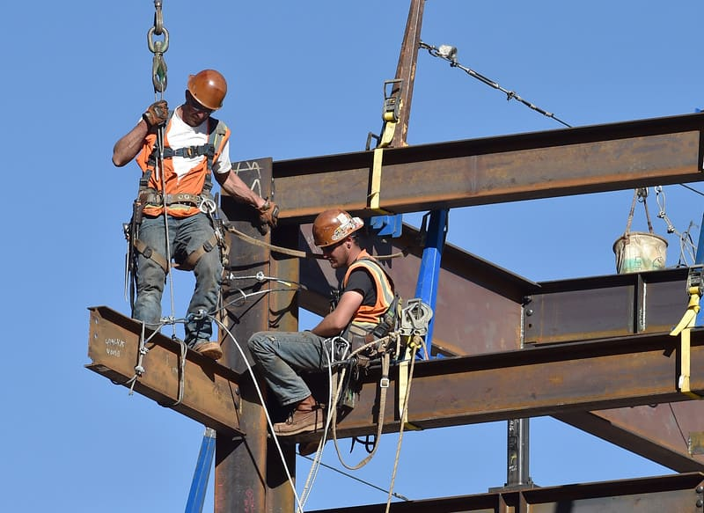

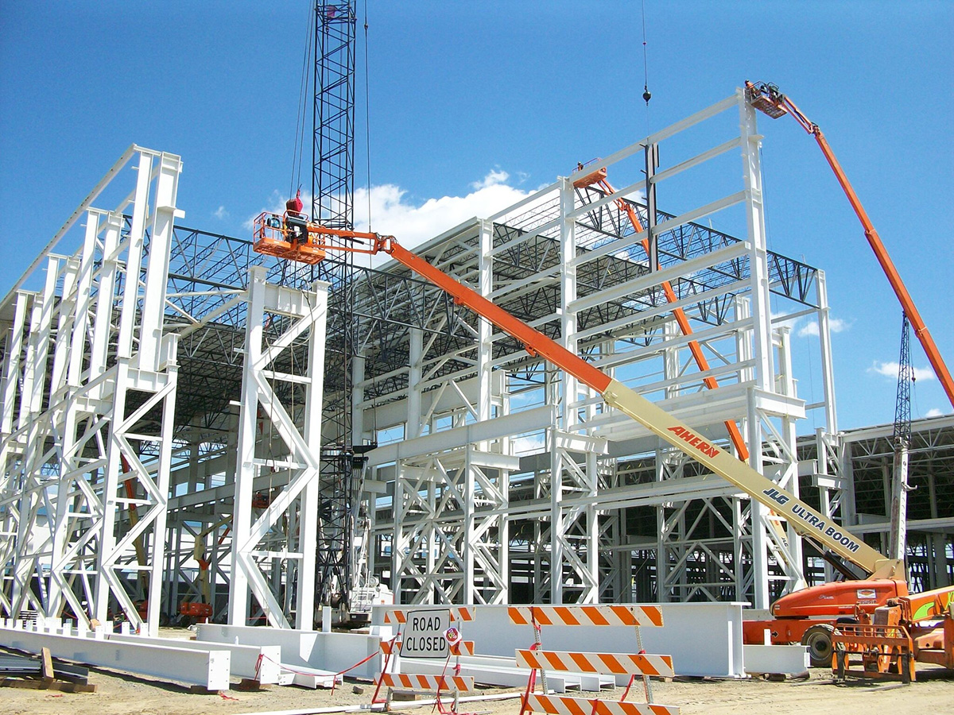

|  |
| --- |
| Precautions: |

1. You should be briefed on the safe system of work before you start. It is important that you understand this.

2. Erection will invariably involve the use of a crane. All lifts must be properly planned and supervised by a competent person and involve the use of qualified slinger signallers.

3. When working at height, work from a stable working platform wherever possible.

4. When a platform is not practical, wear a safety harness and fall arrest device. Ensure that you are clipped to a secure, designated anchorage point at all times. The use of personal fall-arrest equipment would be considered the last resort.

5. Ensure that there is a safe means of access to, and egress to and from, high level places of work.

6. Be aware of the dangers to others below and cordon off the area at ground level. (Drop Zones)

7. The use of cranes will mean that your employer will have to consider:

~Whether the ground conditions can support the crane.

~The area required by the crane as it slews, including, in some cases, consideration for the general public.

~the proximity of buried ducts or pipes that may affect crane stability.

~The location of overhead hazards (such as power lines).

8. Always wear appropriate PPE.

9. Don’t move along beams by straddling unless absolutely necessary and you are clipped to a proper anchorage point – this is a last resort option.

**Discussion Points:**

What measures should be taken to avoid contact with overhead cables?

How can the length of time spent working at height be reduced?

What should your employer consider as the next choice of working at height when it is not practical to erect scaffold?

What type of safety harness and lanyard should be worn, and why?