|  |  |
| --- | --- |
| Reason: | Waste management and control is a vital element in the construction industry. Every year millions of pounds are wasted by poor management of materials and resources. |
| Outline: | This talk covers some important aspects of waste management and control. |

|  |
| --- |
| Waste Management and Control: |

1. The golden rules are:

Prevent – Avoid producing waste in the first place.

Reuse – Use items as many times as possible (where appropriate).

Recycle – Recycle what you can only after you have reused it.

Recover – Send what cannot be recycled to another form of energy recovery, to produce energy.

Dispose – As a last resort, send the waste to landfill for disposal.

2. Waste comes from many sources, including contaminated ground, road sweeper arisings, excavations, damaged materials, off-cuts, and leftovers (mortar, concrete, plaster, plasterboard, paints, solvents, and so on). Anything not used is classed as waste if you intend to discard it.

3. Minimising waste by following the golden rules takes more effort but is good for the environment and the company.

4. Segregating waste into hazardous, non-hazardous, and inert types for disposal or recycling maximises opportunities for recovery costs and penalties can be avoided.

|  |
| --- |
| Control Measures: |

❶Store materials properly and safely to prevent damage before use.

❷Keep significant off-cuts for reuse and know the correct place to stockpile and protect materials for reuse.

❸Consider the quantity of material to be used before ordering or opening a pack and use it all before opening a new pack.

❹Reuse materials (such as formwork and shuttering) where practical.

❺Tell management about instances in your work where you could reduce waste.

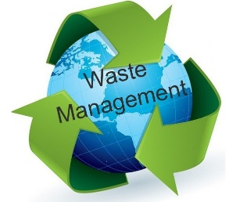

|  |
| --- |
| Precautions: |

1. Do not place materials for reuse in areas where they could be damaged or be contaminated by other materials.

2. Do not use a new length of timber, pipe, or cable without checking the reusable stock.

3. Do not dispose of contaminated waste, other than in designated areas.

4. Do not overfill skips. If a skip is full tell management.

Do not mix hazardous, non-hazardous, and inert waste together because it prevents recycling and is more costly.

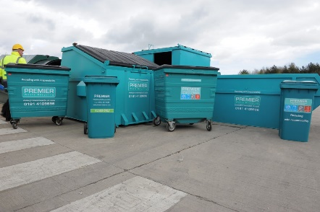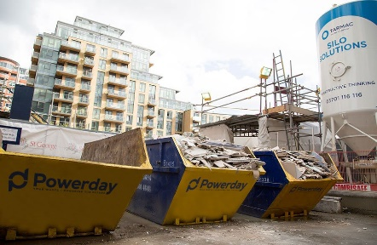

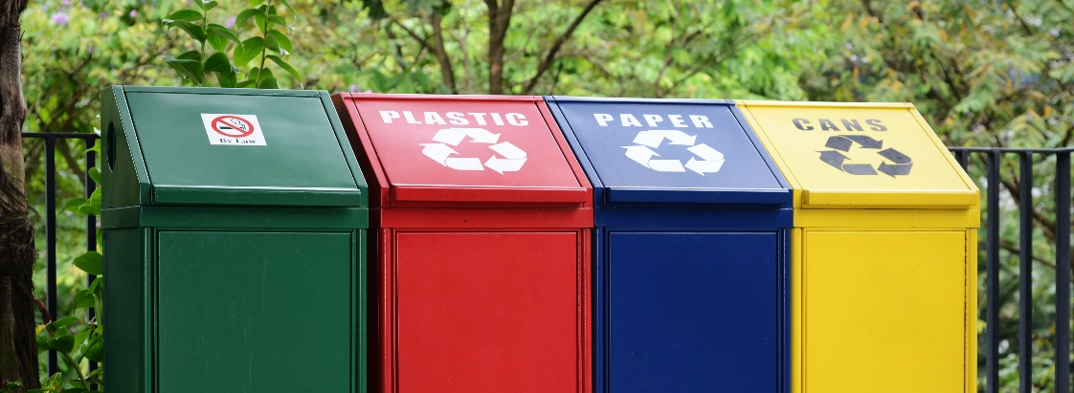

**Discussion Points:**

Why is it important to segregate waste?

What is the workplace policy for recycling & waste management?

What wastes cannot be mixed?

What happens to waste when it leaves site?

What should be done with surplus materials and off-cuts?