|  |  |
| --- | --- |
| Reason: | A confined space can be a hazardous environment. Workers can become trapped or overcome by fumes, vapours, explosives, or poisonous gases. This can lead to serious injury and death. |
| Outline: | This talk covers hazards, before entry, work in confined spaces & emergency procedures. |

Many workers die in ignorance of the dangers of confined spaces.

The dead often include ill-prepared workers.

|  |
| --- |
| Hazards. |

* Oxygen-depleted or enriched environments and suffocating, toxic or flammable atmospheres.
* Actual or potentially hostile environments (inside plant).
* Biological hazards such as Weils disease from rat’s urine.
* Confined Spaces include cellars, chambers, pits, tanks, manholes, sewers, plant rooms, lofts, service tunnels, hoppers, and some excavations. They do not have to be totally enclosed.

|  |
| --- |
| Before Entering a Confined Space: |

1. You must be trained before entering a confined space!

2. Working in confined spaces should be avoided wherever possible.

3. Don’t enter a confined space until a competent person makes a full assessment of the works.

4. A permit system for works in confined spaces must be applied in most cases.

5. Check for flammable or toxic gasses and oxygen content. The RA should identify all potential hazards such as different types of gasses present.

6. If breathing apparatus is required, don’t enter until you are trained to use it and it fits your needs.

7. Obey permits to work and check communications and monitoring equipment.

8. Ensure a means of escape and rescue, and the facility to contact emergency services.

|  |
| --- |
| Working within a Confined Space: |

1. Work will be controlled by a permit to work, which will include arrangements for rescue. No rescue plan/team, No entry! Wear the protective equipment and clothing provided and continuously monitor the air quality. Only use intrinsically safe electrical equipment where flammable gases may be present.

2. Don’t eat, drink, smoke or use a naked flame, or allow exhaust fumes in close proximity of confined space working.

What must you check before entering a confined space?

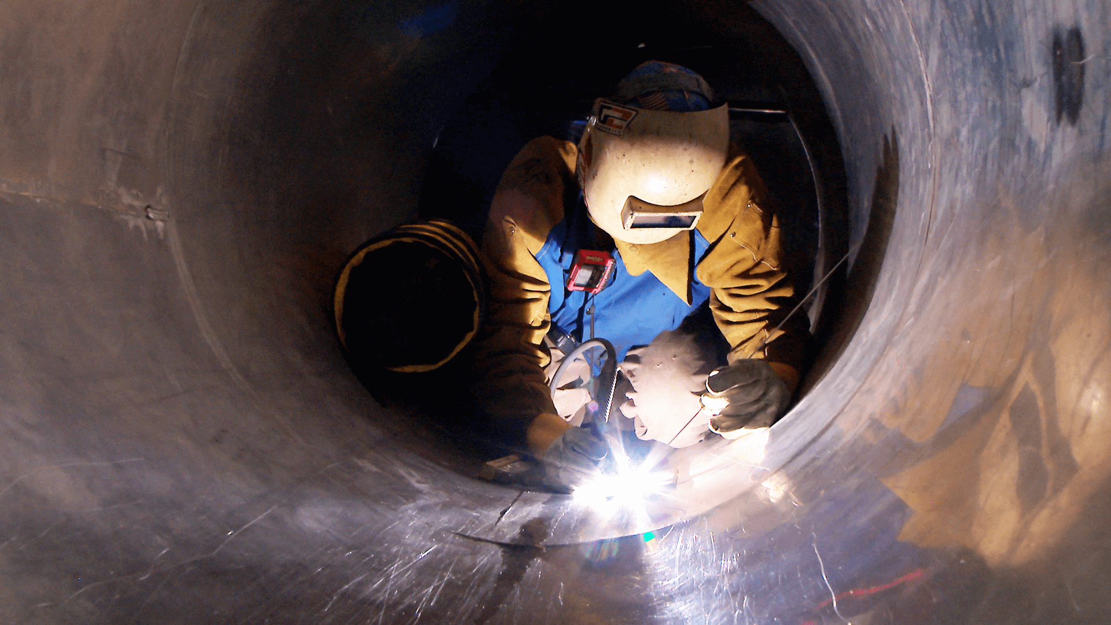

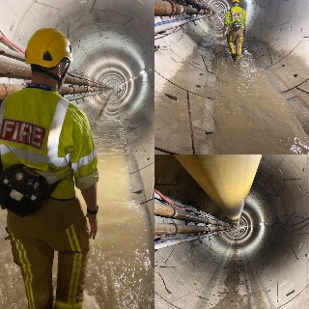

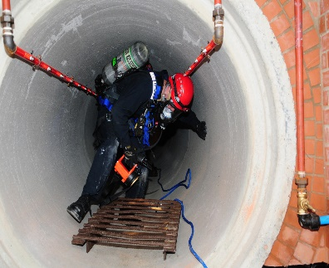

|  |
| --- |
| Emergency Precautions: |

* The first duty of any rescuer is to ensure their own safety.
* Don’t attempt a rescue unless you are part of a trained rescue team.
* Leave a confined space immediately if told to do so.
* REMEMBER always follow the rescue plan.
* Make sure the recovery winch and apparatus is working.
* Locate the position of the nearest telephone and understand the emergency procedure.

**Discussion Points:**

Name 3 safety points regarding confined spaces.

What hazards can be found in confined spaces?

What must you check before entering a confined space?

What can be classed as a confined space?