|  |  |
| --- | --- |
| Reason: | Unseen and unheard, electricity can cause death or serious injury without warning. Your body is an extremely good conductor of electricity – don’t find out the hard way! |
| Outline: | This talk covers overhead power lines and cables. |

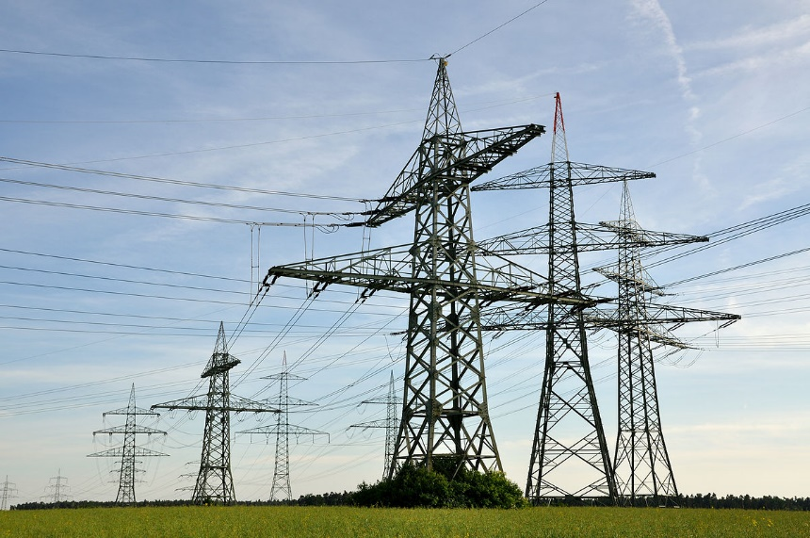

|  |
| --- |
| General Precautions: |

1. Every year people are killed or seriously injured at work when they come into contact with live overhead services. These incidents often involve the examples below:

Machinery – Cranes, lorry-loader cranes, and tipping trailers.

Equipment – Scaffold tubes and ladders.

Work activities – Loading, unloading, lifting, spraying, and stacking.

2. Work may be carried out near overhead services if there is no alternative and where risks are acceptable and can be properly controlled.

3. A risk assessment must be undertaken. Your employer should consult with the electricity supply company, as they will be able to give advice on suitable control measures.

|  |
| --- |
| Overhead Power Lines: |

1. Until it has been proved otherwise, all overhead lines should be treated as live and dangerous.

2. Ensure you know the minimum clearance distances specified by the electricity supply company.

3. Never enter a safety zone without prior authorisation.

4. Do not bypass goal posts, barriers, or other warnings.

5. Check your route is clear of overhead power lines before moving any tall object that could conduct electricity (such as mobile scaffold towers or metal ladders).

6. If signalling, always keep power lines in view. Guide plant under power lines only where goal posts have been erected.

7. Ensure you observe any special precautions laid down by the electricity company before working near to or passing underneath overhead lines.

8. If erecting scaffolding adjacent to power lines, ensure the poles are handled a safe distance away, in line with your employers’ safe system of work.

9. Don’t stack materials or operate tippers under power lines as it will reduce the safe clearance and can result in arcing.

**Discussion Points:**

Who should you ask what the safe working distance is?

When erecting scaffolding close to power lines, what precautions must you take?

As a signaller, what must you always keep in view?

Under what circumstances can you enter a safety zone?

