|  |  |
| --- | --- |
| Reason: | Serious injuries on site caused by falls are preventable. Using personal fall protection equipment can save lives. |
| Outline: | This talk covers aspects that need consideration before, during & after the use of personal fall protection equipment (PFPE). |

**A Harness will not stop prevent a fall, but it will**

**minimise the risk of injury should you fall.**

|  |
| --- |
| Before Use: |

(1) PFPE should always be considered as a last resort. Other, more suitable equipment should be used where possible. Factors to consider include type of work, location, duration of works and frequency. The RA produced for the task should identify the equipment to be used.

(2) You should be trained in PFPE your required to use. (e.g., fall restraint, work positioning, rope access or fall arrest).

(3) All equipment to be inspected & tested regularly, fit for purpose.

(4) Trained in pre-use checks and the type of faults to be aware of.

(5) Briefed on the task to be carried out, including details about safe anchor points to be used and the limitations of the equipment in use.

|  |
| --- |
| Safe Use: |

(1) You must not misuse any equipment that is provided for your safety.

(2) Report any defects immediately, withdraw equipment from use. Do not make running repairs. New equipment to be used.

(3) Only use the designated anchor points instructed and deemed safe to use.

(4) Safe systems of work detailed including a full rescue plan & first aid arrangements.

(5) PFPE must be formally inspected by a competent person:

* Every 6 months for normal use.
* Every 3 months for arduous conditions, applications & environments.
* Interim inspections as determined by the RA.
* Installed systems (Scaffold towers etc.) as per manufacturers recommendations.

|  |
| --- |
| After Use. |

(1) All equipment to be inspected for damage and must be clean and dry before being stowed away.

(2) Any defects with the equipment are to be reported immediately.

(3) Adequate records of the condition and usage of the equipment should be maintained.

|  |
| --- |
| Different types of safe working at height: |

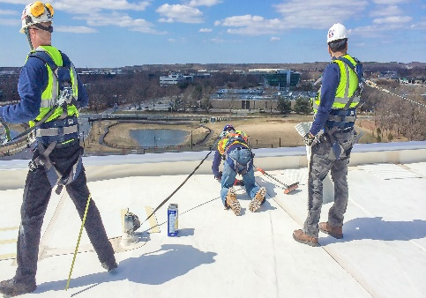 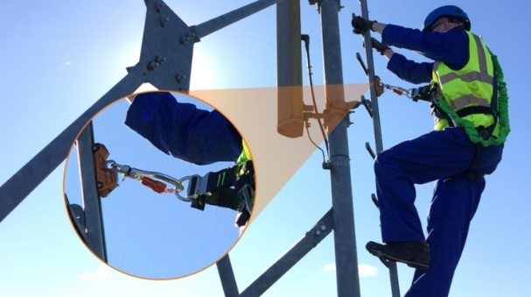

|  |
| --- |
| Typical Safety Harness: |

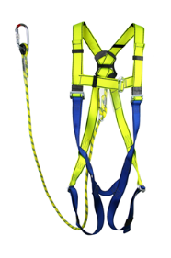 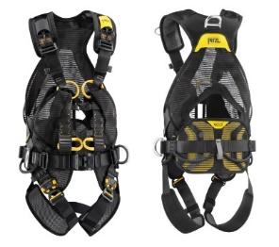 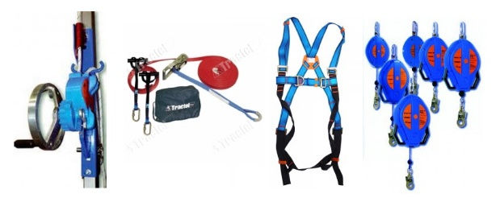

|  |
| --- |
| Points to consider: |

Anchorage points.

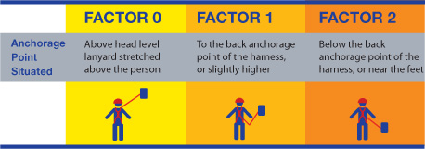

Only use anchorage points specific to the application. These points have been tested and certified to withstand any force created by a fall.

|  |
| --- |
| The ABC of Fall Protection Equipment: |

|  |
| --- |
| Hazards: |

1. Falling and injuring yourself.
2. Falling out of a poorly adjusted harness.
3. The sudden stop of the harness and line may cause shock injuries.
4. Poorly maintained and damaged harnesses will not protect you.
5. Not fixing lanyard to a structure or safety line.
6. Lanyard fixed to an unsuitable anchor point.

**Discussion Points:**

If your harness is damaged, what should you do?

What checks? And how often would you make to your harness?

How do you know which anchor points may be used?

Which document will identify the type of equipment to be used?