|  |  |
| --- | --- |
| Reason: | All work at height must be properly planned. Falls from height account for around 50% of deaths in the industry and if you do not follow guidance you may end up as a statistic or, at best with life-limiting injuries. |
| Outline: | This talk covers access requirements, loading, workplace hazards, inspection & security. |

|  |
| --- |
| Access: |

* Don’t climb up or down scaffolding tubes – use ladders or stairs provided.
* Make sure the ladder is at the correct angle (75°).
* The access ladder is free from debris and obstruction, damage and defects. It must be stable when you climb it or descend from it.
* At the end of a shift, all access ladders should be removed or secured to prevent unauthorised access.
* Ladder gates installed at all access points.

|  |
| --- |
| Loading: |

(1) Don’t overload scaffolding. Position heavy loads adjacent to the standards as they are the load-bearing members, not in the centre of bays. Loading bays should display SWL.

(2) When stacking materials, always leave a passageway at least 2 boards wide for other people to pass, or 3 boards wide if wheelbarrows are in use. Ensure that escape routes are clear so that they can be used in an event of an emergency.

(3) Ensure materials are stacked correctly and can’t fall, use brick guards or netting, where required. Don’t leave tools lying around on the platform.

Where should you stack materials on scaffolding and why?

|  |
| --- |
| Hazards: |

(1) Guard-rails, toe-boards & brick boards must be fitted where people, materials or tools are likely to fall and cause injury.

(2) Don’t use incomplete unfinished scaffolding. Report any concerns to a supervisor.

(3) Don’t interfere with ties, guard-rails, bracing, toe-boards and ladders. Alterations must be made by a qualified competent person.

(4) Don’t throw, drop or tip materials from height. Materials must be handled in a controlled manner. Use a disposal chute.

(5) The gap between toe-boards and mid guard-rails, and between mid and top guard-rails must not exceed 470mm.

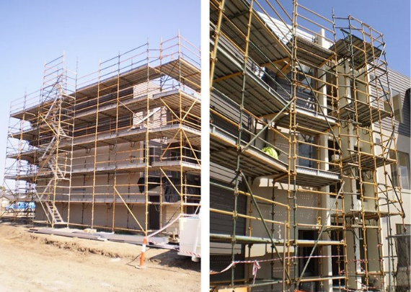 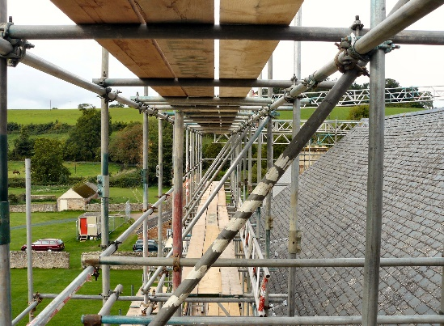

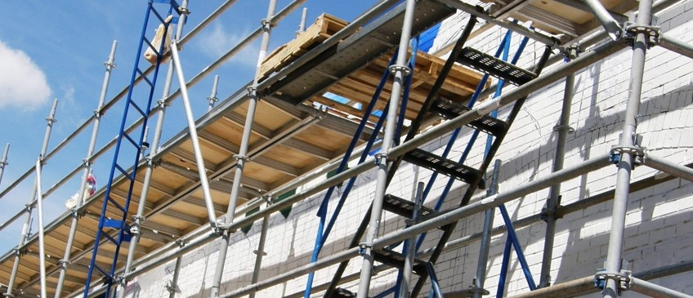

|  |
| --- |
| Inspection: |

Carry out a visual check at the start of each shift, prior to use.

Report any suspected defects immediately.

Scaffolding should be inspected every 7 days or after alteration, modification and any event that may have compromised its stability (e.g. high winds). Inspections must be carried out by a qualified, competent person.

**Discussion Points:**

At what angle should the access ladder be?

What action should you take on discovering defective scaffolding?

How should you dispose of materials at height?

What 2 things should you consider when loading scaffolding?