|  |  |
| --- | --- |
| Reason: | MEWPS are used extensively to gain access. When used responsibly and safely, a MEWP can significantly reduce the risk of injuries from falls from height. They are useful items of plant but can be dangerous if not used in a safe manner. |
| Outline: | This talk covers the hazards and safe operating methods for MEWPs. |

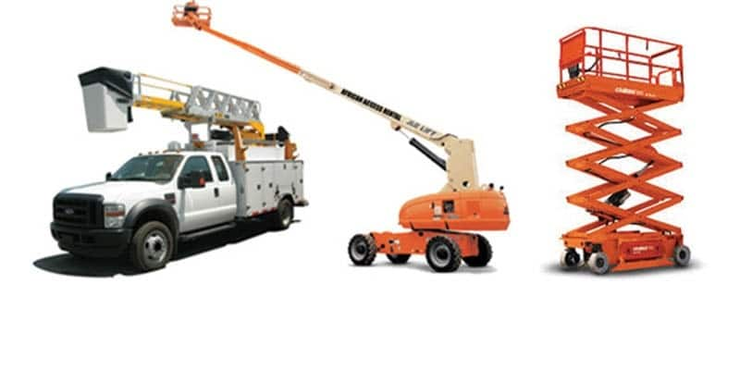 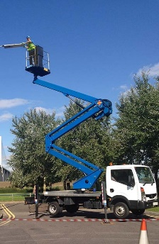 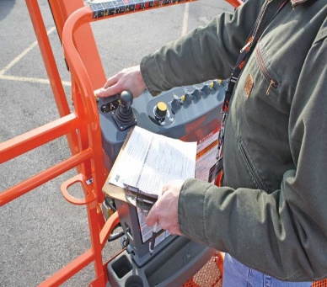

|  |
| --- |
| Hazards: |

(1) Operatives falling from height due to unsafe practices.

(2) Overturning of the machine due to poor operating technique or unsatisfactory ground conditions.

(3) Collision with other vehicles.

(4) Entrapment of the operator between the basket and structures.

(5) Involuntary operation of controls.

(6) Leaning over the platform guard-rails or control panel.

(7) Poor lighting levels.

(8) Tools and materials falling from height, from the basket or dropped.

(9) Contact with high level, live electrical cables, and other obstructions.

(10) High wind speeds and other adverse weather conditions.

|  |
| --- |
| Precautions: |

(1) The use of MEWPS should take place in line with a documented safe system of work (lift plan). In addition, a rescue plan must be in place to enable the prompt recovery of injured workers.

(2) All operators of MEWPS must be trained and certified & competent in their use, and only use the type of MEWP they are qualified to use.

(3) Pre-use checks include:

* Suitable ground conditions.
* Suitable weather conditions.
* Ground & basket controls in full working order.
* Fall protection equipment safe and in correct use.
* Brakes, oil, tyres.
* Check all guards & safety devices are in place & work efficiently.

(4) Do not load the machine beyond its SWL (safe working load).

(5) If your work involves removing equipment or materials from a structure, allow for this extra loading.

(6) Always use a banksman where manoeuvring in tight spaces or where the public are at risk.

(7) Be prepared to stop work and return to ground level if weather conditions deteriorate.

(8) Anti-entrapment devices, proximity alarms can prevent crushing.

(9) Don’t travel with personnel in the basket unless the machine is designed to.

(10) Ensure an evacuation procedure (rescue plan) are in place should the machine break down.

(11) Always access the basket and load tools and materials at ground level.

**Remember:** Use the equipment properly and in the manner it should be used and working at height will become much safer!

**Discussion Points:**

What particular hazards are present in your current workplace?

Why do you not clip onto a structure?

How can you find out who is qualified to operate a MEWP?

Why are gound conditions and weather crucial in the operation of a MEWP?