|  |  |
| --- | --- |
| Reason: | Mobile access towers must be erected in accordance with the manufacturers’ instructions and only suitably trained and competent individuals. Unless you use a mobile access tower correctly you could find yourself seriously injured or even worse. You may also compromise the safety of those working with you or around you. |
| Outline: | This talk covers the safe erection, use and stability of mobile access towers, and workplace hazards. |

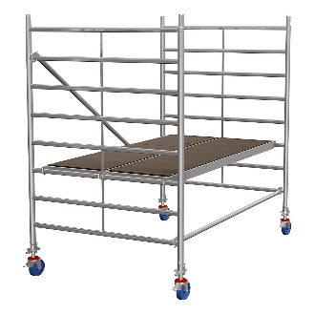 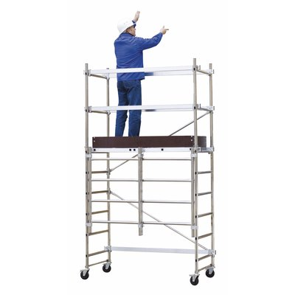 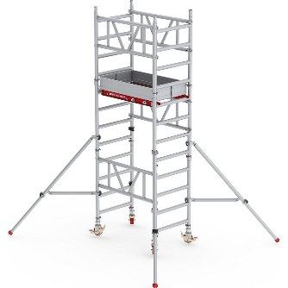

|  |
| --- |
| Before Erecting the Tower: |

1. Ensure you are qualified and competent to erect the tower.

2. Choose as a safe method of work as recommended by the Prefabricated Access Suppliers and Manufacturers Association (PASMA).

3. Check all components are in good condition (such as outriggers, brakes, & locking devices).

4. You should have access to the towers’ manufacturers instruction manual.

5. Ensure that the area where the mobile access tower is to be erected is clear, clean, and free from obstruction.

6. You should work in accordance with the safe system of work following a RA and method statement.

What must be checked before erecting a tower on a suspended floor?

|  |
| --- |
| Before Use: |

❶Ensure the tower is vertical and square.

❷The wheels must be locked when the tower is not being moved.

❸Check the outriggers are set correctly and secured if needed.

❹Ensure the platform is fully boarded out and guard-rails and toe-boards are fitted.

❺Be aware of weather conditions if the tower is outdoors; high winds can blow them over. They should be used in accordance with the manufacturers’ instructions.

|  |
| --- |
| Safe Use: |

* Always use the built-in stairway or ladder. If it is a vertical ladder, always climb on the inside of the tower.
* Follow the manufacturers’ guidelines on base to height ratio.
* Guard-rails should be installed at specified heights.
* Tie the tower to a permanent structure or install outriggers as necessary.
* Don’t move the tower with personnel or materials still on it. Don’t pull along while standing on it. (highly dangerous and the tower can tip over).
* Hoist materials up from the inside of the tower.
* Do not exceed the SWL (Safe Working Load).
* Ensure the platform access hatch is closed when you are working.
* Never add any item to a scaffold tower to gain extra height (e.g., ladders).
* Towers must only be used on firm, level surfaces. Provide support on soft ground.
* Do not remove components such as guard-rails if they are stopping you from working efficiently.
* Before using a tower inspect and ensure a tagging system is in place and it has been inspected within the last 7 days.

**Discussion Points:**

When should toe-boards and guard-rails be fitted?

What hazards must be considered when moving a tower?

Outline 1 pre-erection and 3 pre-use checks.

Outline 1 stability consideration and 1 hazard.

**Remember:** After moving a tower and before use, lock the wheels,

install outriggers!