|  |  |
| --- | --- |
| Reason: | Ladders are probably the most used and misused pieces of access equipment. Using ladders safely will help prevent accidents. |
| Outline: | This talk covers pre-use checks, safe use of ladders, the associated hazards, and restrictions. |

|  |
| --- |
| Pre-use Checks: |

(1) Ladders and stepladders must be stored correctly and inspected regularly.

(2) Check for splits or cracks in the stiles and rungs and check for missing or loose rungs.

(3) Don’t use painted ladders, paint hides faults.

(4) Report defects immediately and remove from use.

|  |
| --- |
| Safe Use of Ladders and Stepladders: |

(1) Only light work of a short duration, with a low risk of falling should be carried out from a ladder. The RA must identify that other forms of access equipment are not suitable due to working conditions before any ladder is considered.

(2) Ladders should be set on a firm base and the lean at the correct angle (1 unit out to 4 units up or 75°)

(3) Ladders should be secured near the top and extend at least 1m above the landing point unless a separate handhold is provided. Ladder tying systems available.

(4) If the ladder cannot be secured at the top, it must be secured lower down.

(5) Ensure your footwear is free from excessive mud/debris before you climb a ladder.

(6) When climbing up or down, use both hands on the stiles and always face the ladder.

(7) Don’t over-reach from a ladder. Always move it.

(8) Tools and materials must not be carried up ladders. A tool belt should be used.

(9) Where a handhold cannot be maintained for anything other than a moment, other fall protection measures are required.

(10) Always report defects and remove from use.

(11) Do not stand or work on the top 3 steps of a step ladder (including a step forming the very top of the stepladder) unless there is a suitable handhold.

|  |
| --- |
| Hazards: |

* Never stand a ladder on a drum, box, pallet, bricks, mobile access tower or any other unstable base.
* Never attempt to use or repair broken ladders.
* Only light materials and tools may be carried up ladders in line with the RA and manufacturers information. Use a tool belt.
* Don’t over-reach or apply a side loading when working from a ladder or stepladder.
* When using ladders, make sure there are no electrical hazards nearby (such as overhead power lines/cables).

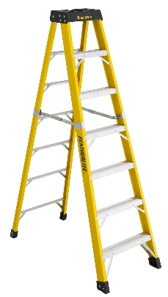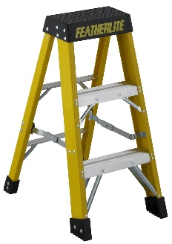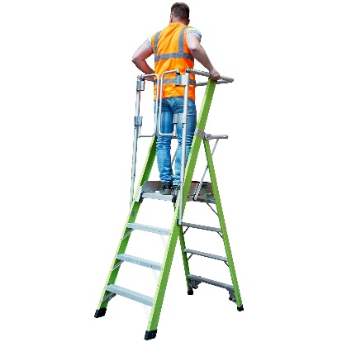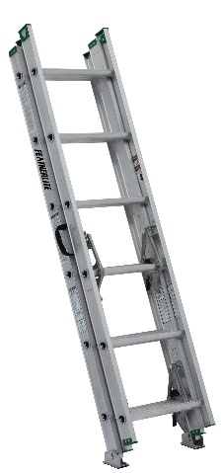

|  |
| --- |
| Before Using a Ladder: |

The law requires that careful consideration be given before work is carried out from a ladder and is only allowable if its short duration (less than 30 minutes) and has been justified by a risk assessment.

**Remember:** Other forms of access equipment will often be more suitable.

**Discussion Points:**

What checks should you carry out before use?

At what angle should a leaning ladder be places?

How can the stability of the ladder be improved?

What precautions should you take when using a metal ladder?

What should you do on finding a defective ladder?

What is the correct way to climb a ladder?

Before using a stepladder, what should you check?