|  |  |
| --- | --- |
| Reason: | Around 7 people are killed each year from falling through fragile roofs. They can be prevented by careful planning, using trained & experienced workers and suitable equipment. |
| Outline: | This talk covers some of the types of fragile roofs, what you need to do before and during work, and the requirements for working on fragile roof surfaces. |

|  |
| --- |
| Types of Fragile Roof: |

* Cement Sheeting – non reinforced sheets e.g., asbestos cement roofing sheets.
* Roof lights – these are difficult to see in certain light conditions 7 when subject to weathering.
* Liner panels on built-up sheeting.
* Corroded metal sheets.
* Glass, including wired glass.
* Rotten chipboard, or similar materials.
* Other materials including wood-wool slabs, slates, and tiles.

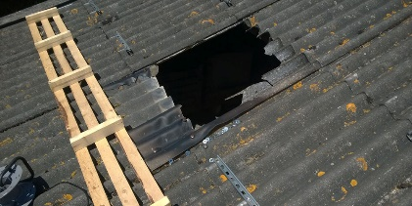 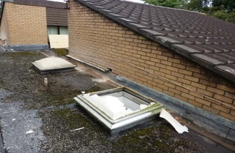 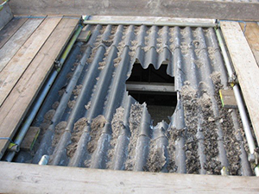

|  |
| --- |
| Before & During Work on Fragile Roofs: |

(1) Planning & supervision are key to reducing the risk of a fall. Work should not start until the findings of a RA have been considered, the working party briefed on their contents and suitable control measures in place.

(2) Before going on or near a fragile roof or surface, can the work be done using another method of access? A safer way? (MEWP).

(3) If going on a fragile roof is necessary, a planned safe system of work must be in apparent.

(4) Safety should be monitored as work progresses and changes made if required.

If nets, airbags, or other soft-landing systems are used, they should be professionally installed by qualified personnel and inspected regularly.

(5) Crawling boards and ladders must be provided and used where the roof is sloping with a pitch of over 10°.

(6) Where work is of short duration and the provision of guard-rails and toe-boards in impracticable, safety harnesses must be used with suitable anchorage points.

(7) Openings must be covered or guarded, if removed for the passage of workers or materials, replace immediately.

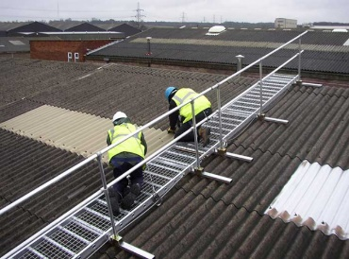 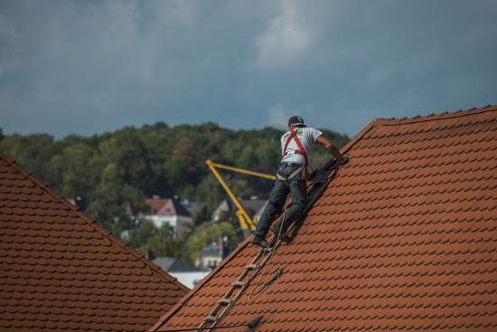 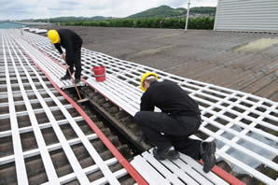

|  |
| --- |
| Requirements for Working on fragile Roofs: |

* Ideally a safe system of work should be identified to enable the job to be carried out without anyone having a to go on the roof.
* Where this is not possible, suitable edge protection must be installed and a platform provided from the access point to the work area. Reducing the need to walk on the fragile roof.
* Access platforms and walkways should be fitted with guard-rails, where this isn’t possible, safety nets, air bag systems running lines etc to be employed. Safety harnesses and lanyards in use.
* If safety harnesses are used, they should be appropriate to the task and only used if there is a safe and secure anchorage point.
* Emergency arrangements to be made should an incident occur. Rescue plans etc.

**Discussion Points:**

Why is it important to be able to recognise a fragile roof?

What should the first thought be when thinking about working on a fragile roof.

Name 3 things that suggest a roof is fragile?