|  |  |
| --- | --- |
| Reason: | All work at height must be carefully planned. Around half of all fatalities on construction sites are because of falls from height. |
| Outline: | This talk covers what you need to think about and do, before and during working at height. |

|  |
| --- |
| Hazards: |

(1) The incorrect selection or use of access equipment for the task in hand is one of the biggest causes of falls from height. Never use the wrong piece of equipment just because it is all you have available.

(2) Adverse weather conditions must be anticipated, and suitable precautions taken wet, windy & icy weather in particular.

(3) Too much material on a working platform can make access difficult or make the platform unstable.

(4) Don’t allow rubbish to accumulate. Use a chute or lower materials properly.

|  |
| --- |
| Before working at Height: |

(1) All work at height must be avoided where possible. If it cannot, then a collective system to prevent falling (scaffold, MEWP, mobile tower) should be used.

(2) All working at height must be carried out in accordance safe systems of work.

(3) The consequences of any fall should be minimised by using a safety harness or net.

(4) Correct selection of work equipment to be used for the task in hand.

(5) All equipment must be inspected and maintained.

(6) Ensure you have the correct training and instruction to use the machinery supplied. Operators licences etc. Experience, skills, and knowledge.

(7) Ladders/stepladders for light, short duration jobs with low risk of falling.

(8) Fall protection used where applicable (edge protection, barriers, scaffolds).

|  |
| --- |
| Safe working on Roofs. |

(1) Fragile surfaces identified with adequate signage. Eliminate risk of falling through.

(2) Safe systems of work implemented should a risk of falling through be apparent.

(3) Always use a harness and lanyard, a secure anchorage point & training in use.

(4) Openings must have a cover/guard.

(5) Safe means of access (temporary staircase, fixed ladder with gate).

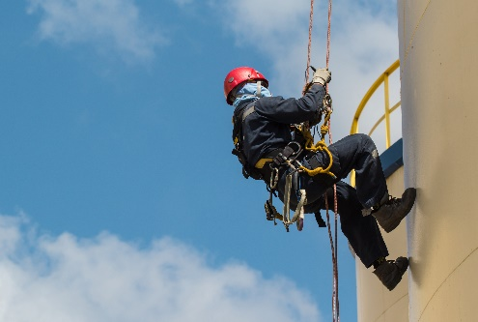 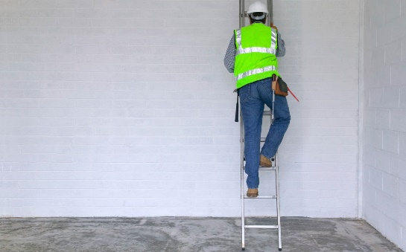

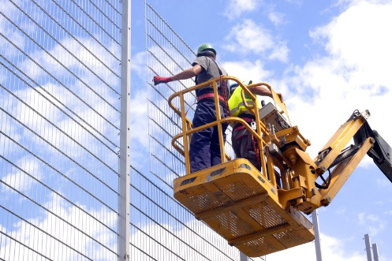 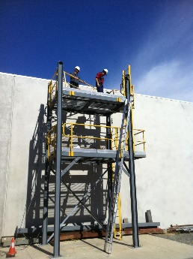 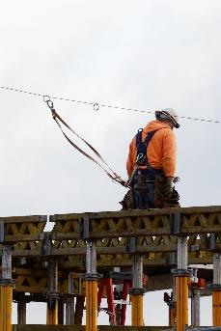

|  |
| --- |
| Before working at Height, Work Through the Following Steps: |

**Avoid** – *Avoid* working at height wherever possible.

**Prevent** – Where working at height cannot be avoided, *prevent* falls using either an existing place of work which is already safe, or by using the right sort of machinery and equipment to support your work.

**Minimise** – the distance and consequences of a fall, again by using the right type of machinery and or equipment and other safety equipment such as harnesses, PPE etc.

**Collective Measures** – Always consider measures that protect everyone at risk, rather than just the individual.

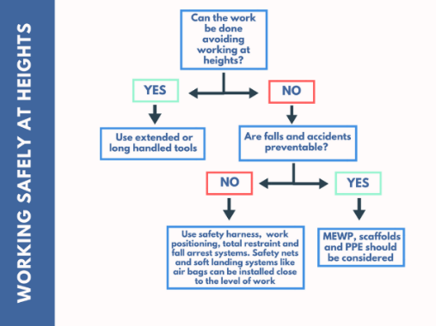

|  |
| --- |
| Do’s and Don’ts. |

Do:

* As much work as possible from the ground.
* Ensure workers can get safely to and from where they are working at height.
* Ensure equipment is suitable for the job, stable and strong enough. Maintained and checked regularly.
* Take precautions when working near fragile surfaces.
* Provide protection from falling objects.
* Consider emergency evacuation and rescue procedures.

Don’t:

* Overload ladders – Consider equipment or materials workers are carrying with them.
* Overreach ladders or step ladders.
* Rest a ladder against a weak surface.
* Let anyone who is not competent work at height.

**Discussion Points:**

What is the definition of Working at height?

What should be identified before work at height starts?

When might a temporary platform be used?

Above what height must edge protection, toe boards and guard rails be erected?

PPE required?

