|  |  |
| --- | --- |
| Reason: | Lifting accessories must be correct for the job, well maintained and safely used if lifting operations are to be carried out safely. Accidents have occurred because of the failure or incorrect selection and use of lifting accessories. |
| Outline: | This talk covers the use of slings, chains, hooks, and eyebolts, and some of the visual checks that should be undertaken at the start of every shift. |

**PEOPLE CAUSE ACCIDENTS, NOT EQUIPMENT!**

|  |
| --- |
| Slings and Strops: |

1. Check the SWL against the weight of the load to be lifted.

2. Don’t use fibre rope or wire slings for hot loads and keep them away from welding or flame cutting operations.

3. Ensure there are no broken ends in wires and no chafing on fibre ropes.

4. Check the condition of splices, rings, and thimbles on slings.

5. Remember – the load on each leg of a multi-leg sling increases as the angle between the legs gets wider.

6. Protect wire rope or nylon slings from sharp edges.

|  |
| --- |
| Chains: |

1. Make sure that the chain is not kinked or twisted and don’t shorten a chain by knotting it.

2. Never lengthen a chain by joining pieces together.

3. Don’t lubricate chain slings because oil can pick up abrasive materials such as sand or grit.

4. Don’t expose chains to acids or corrosive substances.

|  |
| --- |
| Shackles: |

❶Use the right type of shackle for the job in hand. Don’t use any shackle that isn’t marked with the SWL.

❷Check the bow and pin for damage and destroy it if there is any doubt.

❸When using a shackle with a nut and bolt pin, the pin should be free to rotate when the nut is tight.

Check the centre line of the eye is central with the threaded portion.

|  |
| --- |
| Hooks and Eyebolts: |

❶Check both hooks and eyebolts carefully for cracks, cuts, dents, and corrosion pits.

❷Swivel hooks should rotate freely.

❸Always make sure that safety catches operate freely.

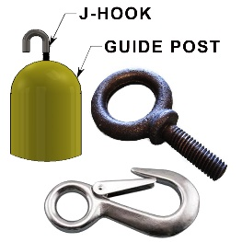 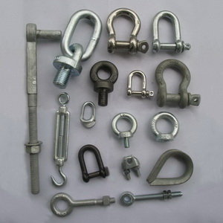 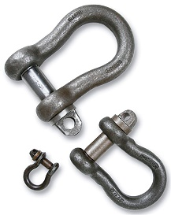 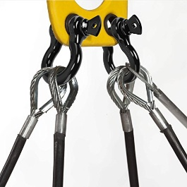

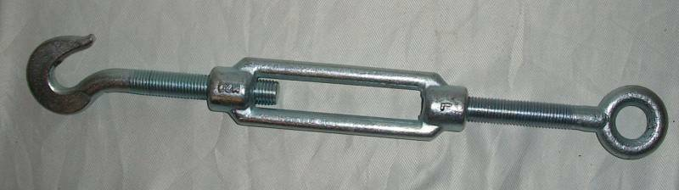

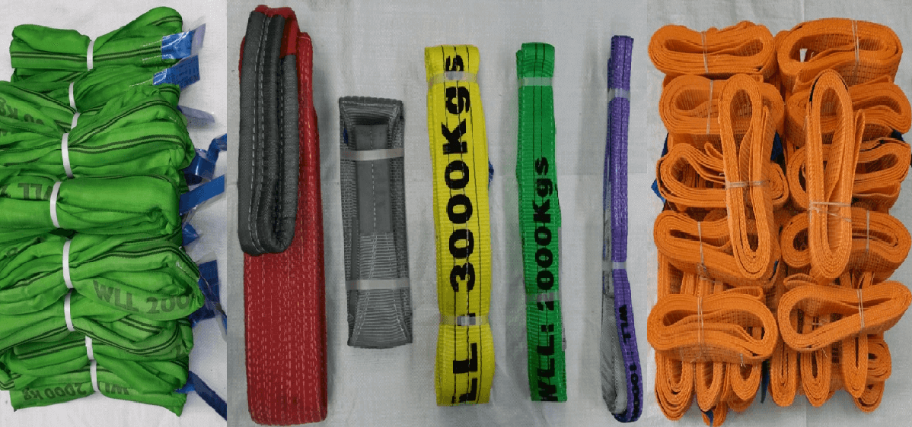 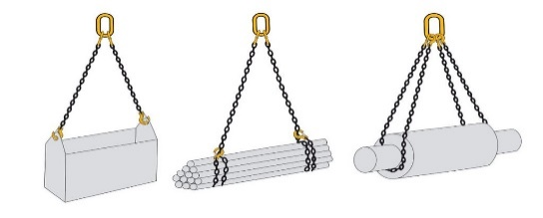

**Discussion Points:**

What information will the lift plan give you?

What must you check before using a sling?

What happens if you double a sling around a shackle?

What should you check on a shackle before use?

What checks should be carried out on hooks and eyebolts before use?

Name 2 things you must not do when using chains?