|  |  |
| --- | --- |
| Reason: | Incorrect slinging, lifting or moving of materials can result in injuries or damage. Loads must be slung correctly to ensure that they do not endanger people on site. Signallers & slingers must be trained and competent to sling and signal safely. |
| Outline: | This talk covers lifting accessories, before lifting, during lifting and potential hazards. |

|  |
| --- |
| Lifting Accessories: |

❶Check lifting accessories for signs of damage and wear before each use. Kinks and frays. Chains must not be joined by means of bolts or wire.

❷Lifting accessories must not be used unless SWL is marked or otherwise known.

❸Don’t use improvised slings or single leg of multiple sling.

❹Store chains, ropes, strops, slings or other accessories in dry clean conditions.

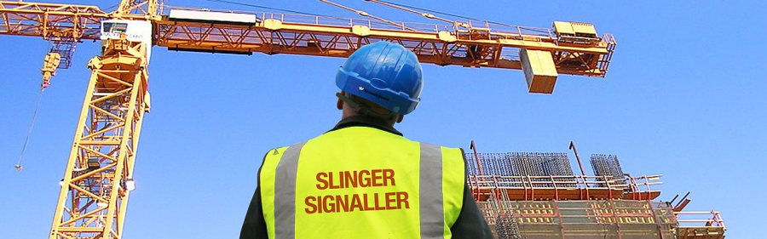

|  |
| --- |
| Before Lifting: |

1. Make sure you understand your role and relevant parts of the lift plan.

2. Wear appropriate PPE (safety helmet, high visibility clothing & safety boots). The machine operator will need to see you at all times, and you need to protect yourself from injury.

3. Make sure you know the weight of the load to be lifted, and if necessary, the centre of gravity.

4. Ensure you can see the operator. If you can’t, use 2-way radios that are fully charged.

5. Ensure hooks are ‘C’ type or fitted with a safety catch.

6. Use the right lifting accessory for the load and ensure it is used correctly.

**REMEMBER:** You are the crane drivers’ eyes and ears!

|  |
| --- |
| During Lifting Operations: |

1. Use approved hand signals clearly and distinctly.

2. Always position yourself in a place of safety. If you cannot see the operator, use a communication system (such as a 2-way radio).

3. Protect wire ropes and slings from sharp edges of the load with softwood or other suitable packing.

4. Ensure the correct pin in the shackle is used and screwed home.

5. Ensure the hook is central to stop the load being dropped and/or swinging when raised.

6. Ensure the load is lifted off the ground, is free and is correctly slung before hoisting.

7. Always use a tag line to steady long loads and stand well clear of the load being lifted.

8. Warn the operator of any obstructions to the load.

9. To avoid damage to slings, loads should be landed on to timber baulks or other suitable bearers.

|  |
| --- |
| Hazards: |

Never tie knots in chains to shorten them and don’t use lifting accessories for other purposes (such as towing).

Keep all those not involved in lifting operations away from the vicinity, especially children and the general public.



**Discussion Points:**

What checks should you make before lifting?

How do you protect lifting accessories from sharp edges?

What must you look out for during lifting operations?

How do you know what lifting accessories to use for a lifting operation?