|  |  |
| --- | --- |
| Reason: | Lifting Operations must be planned and adequately supervised. Unsafe lifting practices can result in accidents and injuries, including fatalities and damage to equipment. |
| Outline: | This talk covers the procedures to follow to ensure that lifting operations are carried out in a safe manner. |

|  |
| --- |
| Types of Lifting Equipment |

Lifting equipment includes items of plant, such as lift trucks, telehandlers, MEWPs, cranes, passenger/goods hoists, lorry loaders, kerb/slab and manhole lifters and pallet trucks.

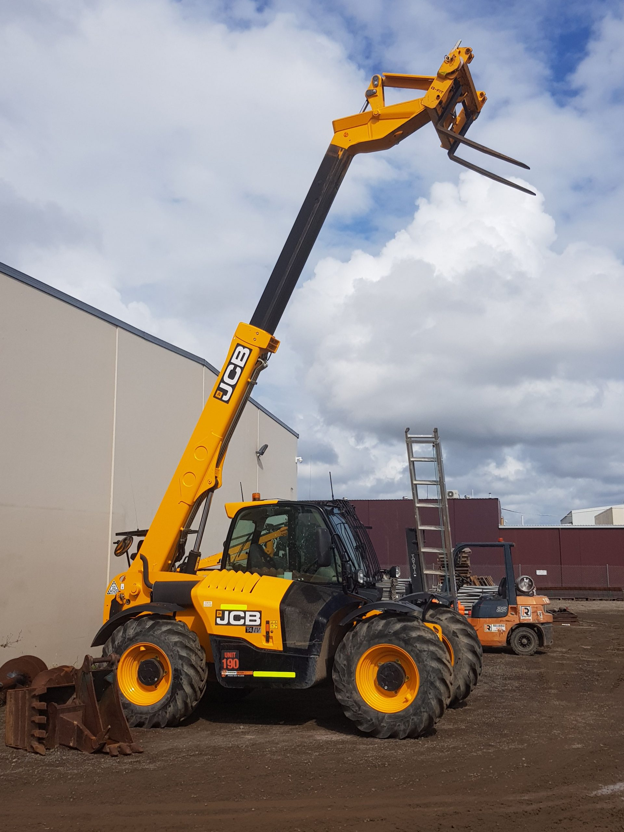

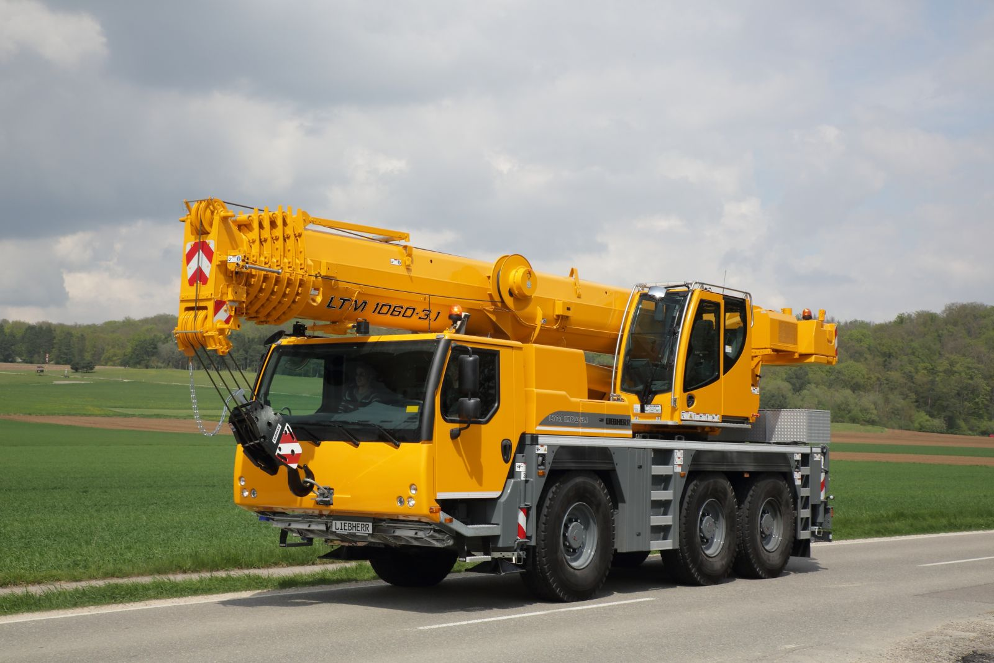

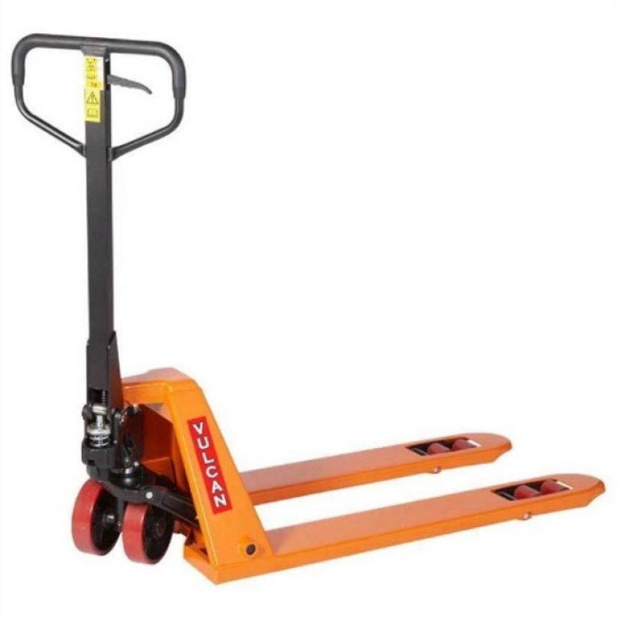

|  |
| --- |
| Precautions: |

❶All lifting operations must be properly planned and appropriately supervised.

❷All lifting equipment & lifting accessories must be marked with their Safe Working Loads (SWL).

❸Lifting equipment & lifting accessories must not be used to move loads heavier than the marked SWL.

❹Lifting equipment must only be used by people who have been adequately trained.

❺Loads must only be slung by qualified personnel. Never stand under a suspended load.

❻When using lifting equipment, look for overhead obstructions i.e., power lines & cables.

❼Carry out a visual inspection of lifting equipment before using it. If it has any defects, do not use it, and report the fault to management.

❽Ensure equipment is not used unless it has been thoroughly examined. Equipment used for lifting persons must be examined every 6 months minimum. Lifting accessories must be examined every 6 months minimum. All other types of lifting equipment must be examined every 12 months minimum.

|  |
| --- |
| Forklift Trucks and Telescopic Handlers. |

1. Travel with the load in the lowest position and don’t raise whilst travelling.

2. Ensure the load is stable and secure.

3. Do not carry passengers unless a passenger seat is fitted.

4. Do not use a forklift truck or telescopic handler to lift people unless it is suitably adapted.

|  |
| --- |
| Cranes: |

1. A qualified person must supervise all lifting operations.

2. It may be necessary to attach tag lines to the load to stabilise it when lifted.

3. Beware of changing weather conditions especially wind speeds making lifting operations unsafe.

|  |
| --- |
| Mobile Elevating Work Platforms (MEWP): |

❶Use only on firm, level ground and use outriggers where applicable and necessary.

❷Users must always use a restraint lanyard clipped to a secure anchorage point within the machine.

**Discussion Points:**

What restriction is there on a load to be lifted by lifting equipment?

Who is allowed operate items of lifting equipment?

How should the load be carried when travelling up a slope?

What checks should you carry out before use?

Which document contains information on the ground conditions required for a lifting operation?

