|  |  |
| --- | --- |
| Reason: | Electrical tools face harsh conditions on site and when misused they get damaged and become dangerous. Incorrectly used and poorly maintained tools can cause electric shock. |
| Outline: | This talk covers pre-use checks, use of electrical tools and hazards. |

|  |
| --- |
| Pre-use Checks: |

❶Make sure the casing isn’t damaged. If it is do not use it and report to management for replacement.

❷Make sure that all cables, plugs, or connectors are sound and not damaged.

❸Check that nay guards fitted can be adjusted properly.

❹Use tools on the correct power supply. Generally only battery-powered or 110v tools are permitted on site.

❺Check to ensure the equipment has had a portable appliance test (PAT) within the last 3 months.

❻Always use tools via an RCD, Residual Current Device.

❼Ensure the cable is long enough to reach the work area without straining.

|  |
| --- |
| Safe use: |

❶Portable electrical tools should only be used for their intended purpose.

❷Ensure switches are working correctly before connecting to the power supply.

❸Wear suitable eye protection if there is any risk to your eyes.

❹Disconnect tools when not in use or when making adjustments.

❺Electrical power tools should be regularly inspected and maintained by a competent person.

❻If using the tool creates dust, you should wear RPE to protect against inhalation.

❼You should be face-fit tested for the type of RPE you are using. This is in addition to primary dust control systems such as on tool extraction.

 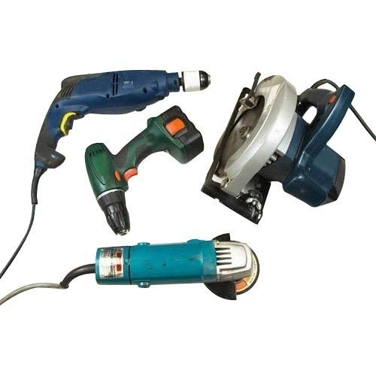







**REMEMBER:** Look after your tools and they will look after you!

|  |
| --- |
| Hazards: |

* If possible, keep power cables off the floor. They may get damaged and cause someone to trip, or they may trail through water.
* Electrical tools often present a noise hazard. Wear hearing protection if necessary.
* Keep equipment clean, tidy and dry.
* Portable electrical tools that have become wet should be allowed to dry and then be checked by a competent person for electrical safety before being used again.
* Some hand-held tools can cause hand-arm vibration. Refer to your risk assessment and the manufacturer or hire company information sheets.
* Never connect a portable electric tool to a lighting socket.
* Don’t use worn, blunt or damaged bits and accessories.

**Discussion Points:**

What should you check before using a portable electric tool?

When drilling, when should you wear eye protection?

What are 3 potential hazards when using portable electric tools?

What does on-tool extraction mean?

What voltage tools should be used on site?

Who should inspect and maintain portable electric tools?

Where can you find information on the correct grade of eye protection for the tool you are using?

