|  |  |
| --- | --- |
| Reason: | Cartridge-operated tools must be used in a safe manner. If cartridge-operated tools are used recklessly by untrained operators’ they can be lethal. |
| Outline: | This talk covers what you should do before use, the hazards and how to use these tools safely. |

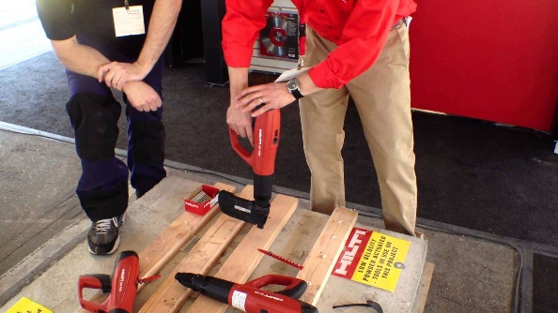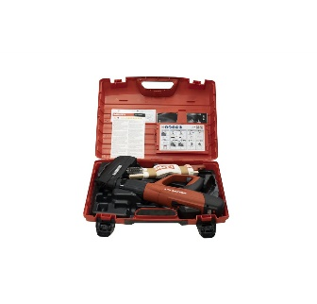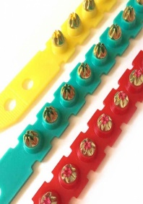

|  |
| --- |
| Before Use: |

* You must be trained, over 18, and authorised to use cartridge-operated tools.
* Read and understand the manufacturers’ instructions carefully before using any tool.
* Load the tool with the barrel pointing away from you and others.
* Never walk around with a loaded tool. Load it before use.

|  |
| --- |
| Hazards: |

1. Using a cartridge that is too powerful for the task.

2. Firing into voids or materials that are too thin.

3. Changes in the consistency of the material.

4. Firing into the hole of a previously attempted fixing.

5. Trying to fix into excessively hard material.

6. The tool is not held square to the surface, or the fixing is too near the edge of the material.

7. Placing parts of the body (such as hands) behind the surface being fixed into.

|  |
| --- |
| Safe use of Cartridge Tools: |

1. Always wear PPE when using cartridge-operated tools.

2. Hold the tool at right angles to the job when firing.

3. Check the material bolt is to be fired into. Carry out a test fire first. Check that no-one is behind or to the side of the target.

4. Allow at least 75mm from edges of concrete or brickwork.

5. Ensure the complete splinter guard is resting on the work surface.

6. Never place your hand over the end of the barrel.

7. In the event of a misfire, wait a minute, do not withdraw the tool, then refire it. If nothing happens, wait a further minute before unloading.

|  |
| --- |
| After Use: |

* Keep the tool clean and well oiled.
* Never leave the tool loaded when not in use.
* Cartridges must be kept under lock and key in a safe place.
* Do not discard new or used caps or cartridges onto the floor within the work area.

**Discussion Points:**

Before using a cartridge tool, what should you do?

What is through penetration caused by?

What are the main reasons for ricochets?

How far from the edge of concrete should the tool be?

What should you do with the tool after use?

If you have a misfire, what should you do?

Before firing into a target, what should you check for?