|  |  |
| --- | --- |
| Reason: | Many accidents involving abrasive wheels are caused by using the wrong type of wheel, use by untrained operators, or as a result of the wheel not being fitted correctly. Without the correct knowledge, accidents will continue to happen. |
| Outline: | This talk covers general precautions when using portable and bench-mounted abrasive wheels. |

|  |
| --- |
| Hazards and General Precautions: |

❶The speed of the machine must not exceed the maximum permissible speed of the wheel. Many accidents are caused by the wheel over-speeding.

❷Don’t mount an abrasive wheel unless you are authorised and trained to do so.

❸Don’t exert heavy pressure on the wheel.

❹Never use the side of the wheel unless it is designed to be used in this way.

❺Hearing and high impact eye protection must always be worn.

❻Where practicable use wet-cutting or on-tool extraction to supress or collect dust.

❼Keep your fingers away from the cutting edge of the tool.

|  |
| --- |
| Safe use of Portable Abrasive Wheels: |

1. Only use reinforced discs on hand-held machines.

2. Never use any equipment without a guard. Adjust the guard to expose the minimum wheel surface necessary for the operation. The machine must be isolated during this activity.

3. Be aware of other workers in your area and don’t put them at risk by your actions.

4. Depending upon what is being cut, it is possible that RPE will be needed. Always refer to the risk assessment provided for the task.

5. Be aware of noise and vibration hazards.

6. Check that the maximum wheel speed is greater than the maximum spindle speed before fitting.

7. Adjust the guard to expose the minimum amount of wheel surface necessary for the operation.

|  |
| --- |
| Safe use of Bench-Mounted Abrasive Wheels: |

1. Adjust the tool rest as close as possible to the face of the wheel and keep the glass screen in the safety position.

2. Keep your fingers below the tool rest level.

3. Use the correct grade of wheel for the work in hand.

4. Keep the face of the wheel evenly dressed and don’t use the side of the wheel.

5. After fitting, run a replacement wheel for a full minute before attempting to use it. Stand clear during the test.

6. Stop the wheel when not in use.

7. It is likely that dust extraction or RPE will be necessary, along with other items of PPE.

8. Make sure that loose clothing does not become entangled in the rotating wheel.

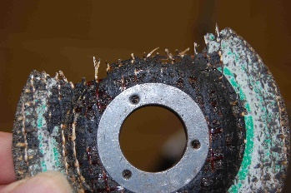 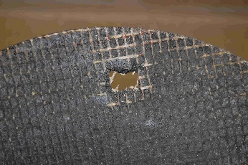 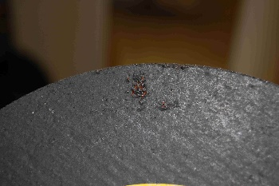

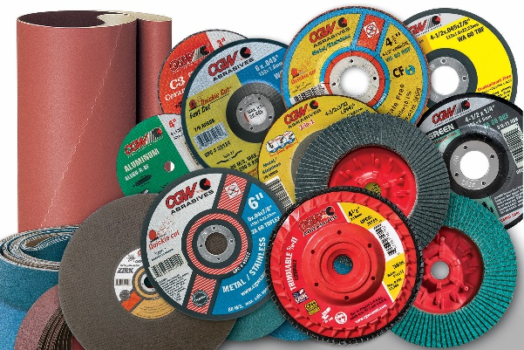

**Discussion Points:**

Why is rated speed of the wheel important?

What grade of eye protection should you wear when using an abrasive wheel?

Where should the tool rest be positioned?

For how long should a replacement wheel be run before using it?

What must be worn when using an abrasive wheel?

Which part of the wheel should not be used?

Who should mount and adjust abrasive wheels?