|  |  |
| --- | --- |
| Reason: | The misuse of plant and work equipment or lack of maintenance can lead to injuries to the user and others. Operators of power-operated plant & equipment must be trained in its use. |
| Outline: | This talk covers safe operating procedures for plant and equipment. |

|  |
| --- |
| Definition: |

Plant and equipment can be mobile or static equipment used in construction.

Examples include:

~Dumper trucks. ~Cement Mixers. ~Cut-off saws.

~Welding sets.

|  |
| --- |
| General Precautions: |

1. Plant & equipment should only be used by people who have been trained and authorised to do so.

2. Consider the risks to other people who are nearby when operating plant equipment.

3. Exclusion zones should be set up where required. These should be identified with safety signage.

4. Before use, ensure that plant & equipment have no obvious defects; report to management.

5. Only use plant & equipment for its intended purpose.

6. Be aware of any pre-use checks and make sure that you carry them out.

|  |
| --- |
| Mobile Plant & Equipment: |

❶Don’t carry passengers unless the plant is designed to do so and wear seat belts where fitted.

❷Observe site speed limits and one-way systems and, if necessary, obtain assistance when reversing.

❸Carry out daily checks (brakes, oil, lights & tyres).

❹Be aware of and avoid crush-zones on rear-wheel steer and centre-pivoting plant.

❺If necessary, vacate the driver’s seat during loading/unloading operations and stand in a designated place of safety.

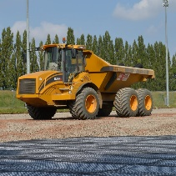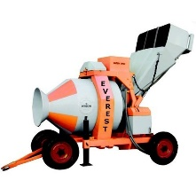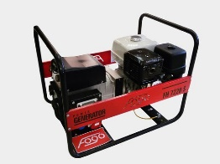

|  |
| --- |
| Static Plant & Equipment: |

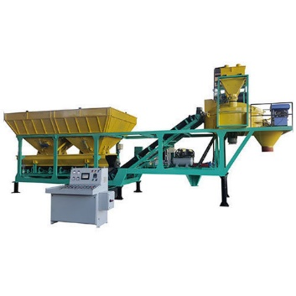 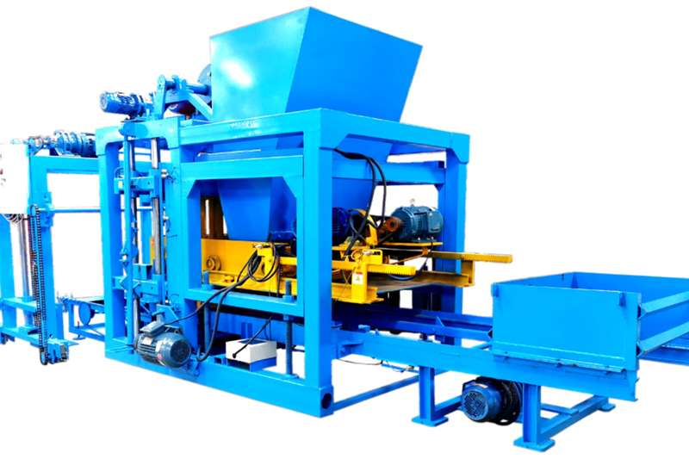

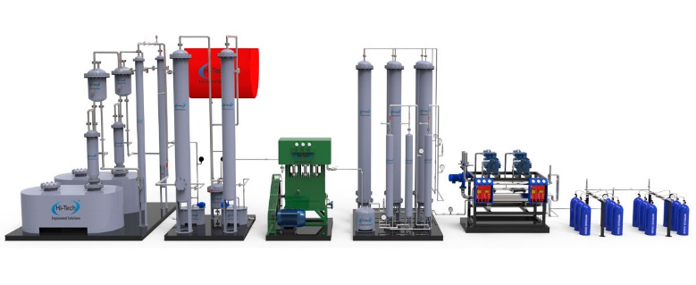

1. If fitted with wheels, ensure brakes are on or wheels are securely chocked.

2. If engine-driven, ensure exhaust gases cannot accumulate.

3. If electrically powered, ensure supply cables and plugs cannot be damaged.

4. Ensure all guards are in position.

5. Consider the need for barriers around the equipment to protect others.

**Discussion points:**

What should happen before anyone is allowed to operate plant or equipment?

What are usual pre-use checks?

What assistance might you need if you are reversing a vehicle?

Why do you need to be trained and authorised in order to use plant or equipment?