|  |  |
| --- | --- |
| Reason: | The amount of plant operating on most sites will generally require the storage and use of large quantities of fuel, which creates hazards. By being aware of the risks, the chance of an accident occurring can be reduced or eliminated. |
| Outline: | This talk covers the hazards created by different fuels and the precautions necessary. |

|  |
| --- |
| Use and Storage: |

❶The most commonly found fuels on site are diesel and petrol (for engines), oil (for gearboxes) and moulds, hydraulic fluid, and grease.

❷Poor storage, lack of care during refuelling, vandalism and poorly maintained plant can all result in spillage.

❸Even a small spill can cause damage to the environment and cause harm to animals, plants, fish, and humans, as well as contaminating watercourses and groundwater.

❹A spillage is likely to be expensive to clean up and there is the likelihood of prosecution and a large fine.

❺Storage areas must be secure, well ventilated, and away from sources of ignition.

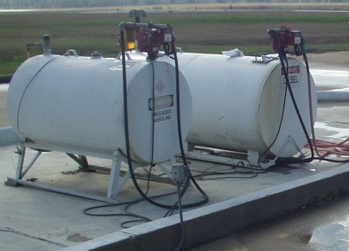 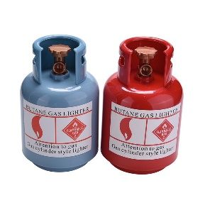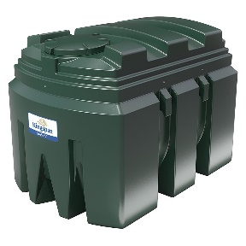

|  |
| --- |
| Control Measures: |

❶Ensure that bulk fuel and oil storage tanks are bunded with a capacity of 110% and kept secure (locked when not in use) and checked regularly.

❷All containers should be stored in secure, bunded areas with a capacity of at least 25% more than the total volume of the containers.

❸Refuelling should be carried out by authorised people in controlled areas, where possible, and drip trays or absorbent mats placed under static plant.

❹All fuel deliveries should be supervised.

❺Spill kits should be available near the refuelling operation and drain covers should be provided.

❻Clear up minor spillages immediately and report the incident to management.

❼Seek advice before attempting to dispose of fuels, oils and contaminated water or ground materials.

|  |
| --- |
| Petrol: |

1. Usually, only small plant (such as disc-cutters & chainsaws) now run on petrol.

2. Petrol fumes are highly flammable – only refuel plant in well ventilated areas.

3. Do not store excessive quantities of petrol.

4. Petrol must only be stored in purpose designed containers – 10 litres maximum (5 litres in a plastic container).

5. No smoking or other sources of ignition are allowed in areas where petrol is stored or decanted.

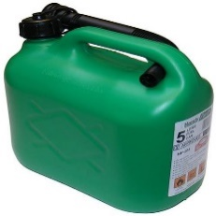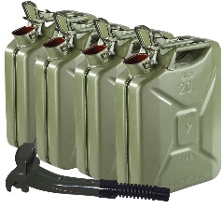

|  |
| --- |
| Diesel: |

1. Diesel should only be stored at a designated refuelling point.

2. Protective gloves should be worn when handling diesel oil because skin contact can result in irritation.

3. As an oil, spilt diesel will cause a slip hazard on hard surfaces.

4. Diesel oil should be stored in either double skinned bowsers or tanks. Diesel stored in metal drums or cans should be stored on drip trays within a secure area.

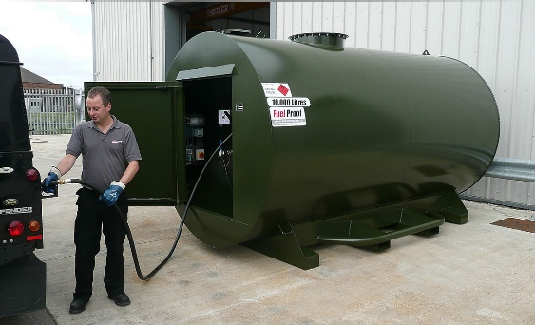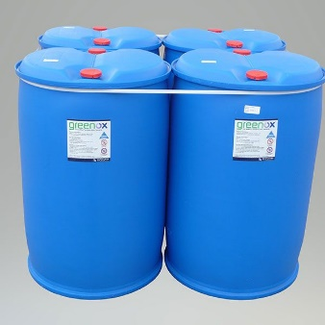

|  |
| --- |
| Liquified Petroleum Gas (LPG): |

❶LPG is used mainly as a fuel for small plant vehicles (such as dumpers & forklift trucks).

❷Cylinders are of special construction and designed to be mounted on their side.

❸Cylinder connectors and other unions have a left-handed thread.

❹Use the correct size spanner for tightening connections; hand-tight connections will leak.

❺LPG vapour is heavier than air; leaks will accumulate at floor level or in drains if not allowed to disperse.

❻LPG vapour is highly flammable and must be kept away from sources of heat, naked flames, and sparks.

❼if LPG cylinders are being heated in a fire, evacuate the area immediately.

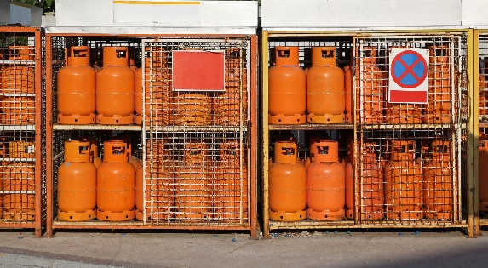 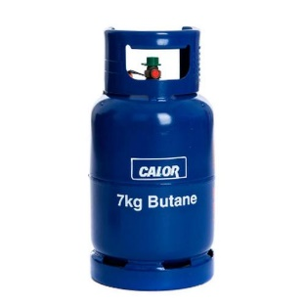

|  |  |
| --- | --- |
| Precautions: |  |

* Do not pour waste or wash spillages of fuel or oil down drains.
* Do not store or carry out refuelling within 10m of a watercourse or drain.
* Do not leave refuelling hoses outside bunds after use.
* Always return containers to bunded areas after use.
* Do not allow drip trays to overflow or leave a tank to fill unsupervised.

**Discussion Points:**

How do you reduce the chance of diesel spillage when refuelling plant?

What should you do in the event of an emergency, such as fuel spillage or fire?

What arrangements should be made for the storage of LPG cylinders?

How can you prevent the accumulation of leaking LPG at floor level?

What type of fire extinguisher should you have available for hot work using LPG?

What is the maximum capacity of a bund?

How far from a watercourse should fuels and oils be stored?