|  |  |
| --- | --- |
| Reason: | Compressed gases, if used safely, are a convenient and valuable source of energy. If you know how to use them safely you can prevent serious accidents and injury. |
| Outline: | This talk covers hazards, use, storage, and transportation. |

|  |
| --- |
| Hazards: |

❶Treat every cylinder as being full and handle carefully.

❷Keep cylinders away from sun, artificial heat, flammable materials, corrosive chemicals, and fumes.

❸Avoid damage to valves and fittings. Don’t use them for lifting or carrying.

❹When using mixed gases (such as welding), flashback arrestors must be fitted.

❺Don’t smoke when using compressed gases,

❻Don’t use cylinders as rollers for moving equipment.

❼If gas cylinders are being heated in a fire, call the emergency services, and evacuate the area.

|  |
| --- |
| Safe Use: |

1. Regular inspection of hoses, cylinders and valves should be undertaken before use.

2. Open cylinder valves slowly and close sufficiently to shut of gas supply – never use force.

3. Ensure that gloves (if worn) are free from oil and grease.

4. Keep valves and fittings of oxygen cylinders free from oil and grease.

5. Keep gas hoses clear of traffic to prevent them being damaged.

6. Know what to do in an emergency.

7. Ensure a fire extinguisher is always available for hot work but only try to fight secondary fires.

8. If there is a hot-work permit or procedure, follow it.

|  |
| --- |
| Storage and transportation: |

❶Always secure acetylene cylinders in an upright position.

❷Store all cylinders so that they cannot fall or roll (such as in a secure, lockable cage).

❸Always lift cylinders from trucks, don’t drop or slide them.

❹Move full size cylinders using a trolley. If one is not available, get assistance.

❺Transport cylinders in vehicles with good ventilation.

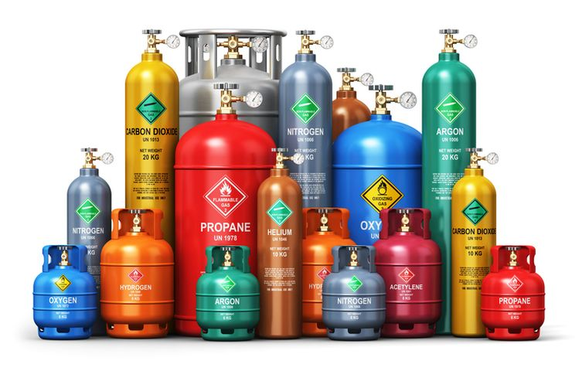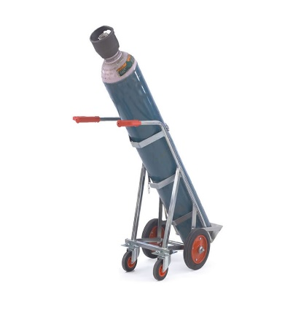

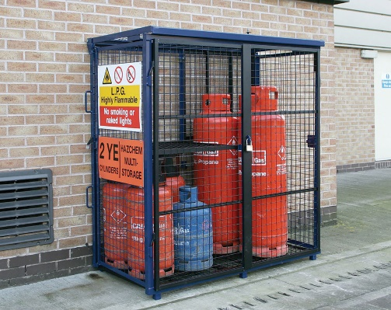

**Discussion Points:**

What should not be used for carrying a cylinder?

If a cylinder is being heated by a fire, what is the hazard?

What should be done before using compressed gases?

What must you remember when working close to traffic?

How should cylinders be stored and transported?

What cylinder must be kept free of oil and grease?

How must cylinder valves be opened?