|  |  |
| --- | --- |
| Reason: | Fire in the workplace causes many deaths and life altering injuries every year. Knowing how to prevent a fire can save lives. |
| Outline: | This talk covers fire prevention, precautions, types of extinguisher and actions on fire. |

|  |
| --- |
| Fire Prevention: |

1. Don’t hang clothing over or near heating equipment.

2. Don’t let paper, oily rags or other rubbish accumulate and don’t smoke in prohibited areas.

3. Use purpose-built containers when handling or storing flammable liquids, not open tins or buckets.

4. Don’t overload electrical sockets – one socket, one plug.

5. Handle flammable liquids at a safe distance from possible sources of ignition.

6. Ensure there are no adjacent flammable materials before using blowlamps and cutting equipment.

7. Bitumen boilers, soldering irons and gas rings must be on non-combustible stands.

8. When electrical equipment is not in use, switch it off: beware of heat produced by halogen lamps.

|  |
| --- |
| Fire Precautions: |

1. Make sure you know what to do in case of fire.

2. Make certain you know your escape routes and assembly points.

3. Keep escape routes clear and unobstructed.

4. Don’t obstruct access to fire-fighting equipment.

5. Only attempt to fight a fire if you have been trained to select and use a fire extinguisher.

|  |
| --- |
| Fire Extinguishers: |

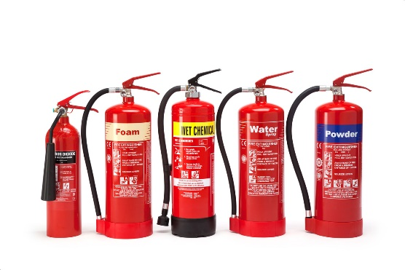

Red – Water.

Paper, wood, textile & solid materials

Cream – Foam.

Fires caused by liquids.

Yellow – Wet chemical.

Wood, paper, textile, cooking oil, & solid materials.

Black – Carbon dioxide.

Liquid and electrical.

Blue – Dru powder.

Liquid & electrical.

|  |
| --- |
| In the event of a Fire: |

* Raise the alarm, call the emergency services and tell management.
* Close doors and windows to prevent the spread of fire.
* Evacuate the building or area you are working in.
* If trained, and you need to, fight the fire with extinguishers provided. Don’t put yourself at risk, always ensure you have an escape route.

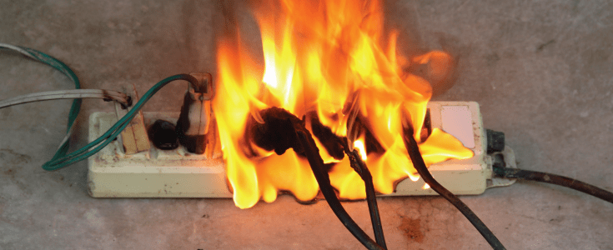

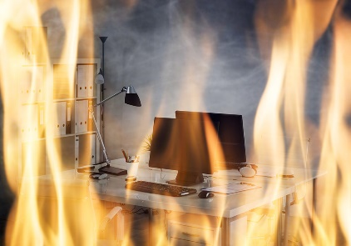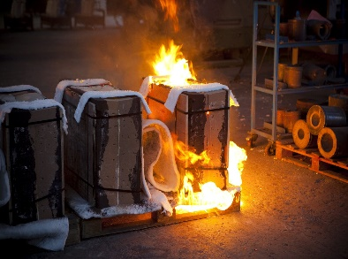

**Discussion Points:**

What should flammable liquids be stored in?

What checks should you carry out before & after using cutting & welding equipment?

Name the precautions concerning extinguishers & fire exits.

What type of fire can a water extinguisher be used on?

What actions should you take upon discovering a fire?

What extinguisher must be used on liquid fires?

List 5 ways of preventing fires in the workplace.