|  |  |
| --- | --- |
| Reason: | Safety signs are an important tool for making workers, visitors, and others aware of hazards, information, and emergency procedures on site. Employers should display signs as a reminder of important information. Safety signs are colour coded as required by the health and safety (signs and signals) Regulations and apply to all places of work. |
| Outline: | This talk covers safety signs you may come across whilst doing your job. |

|  |
| --- |
| Categories and What they Mean: |

**Prohibition Signs** are round and red, with a diagonal red line. These inform you of the things you **must not do**. They stop behaviour likely to increase or cause danger, for example ‘No Smoking’ or ‘No Access for Pedestrians’.

**Warning Signs** are triangular and yellow with black edging. These warn you of a **Hazard or Danger**, for example ‘toxic material’ or ‘overhead load’.

**Mandatory Signs** are round and blue with a white pictogram. These inform you on things you **must do**, therefore prescribing a specific behaviour, for example ‘safety gloves must be worn’ or ‘ear protection must be worn’.

**Emergency Escape or First Aid Signs** are rectangular or square and are green. These give you **Information** on first-aid, emergency exits, or first-aid facilities, for example the location of the eye wash station or safety shower.

**Fire-Fighting Signs** are rectangular or square on a red background. They indicate the location of the facilities associated with fire safety, for example the location of the fire extinguisher or emergency fire telephone.

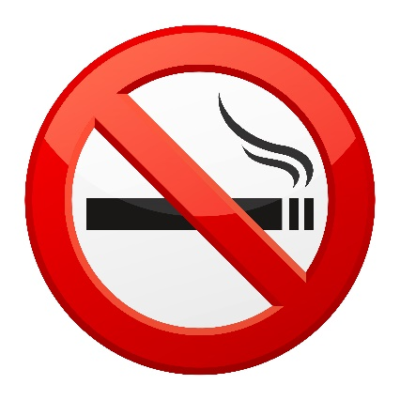 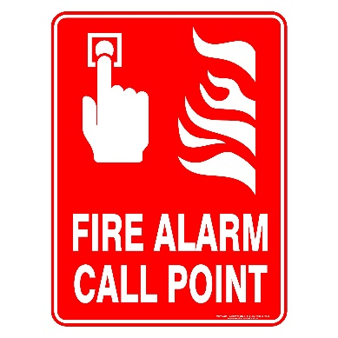

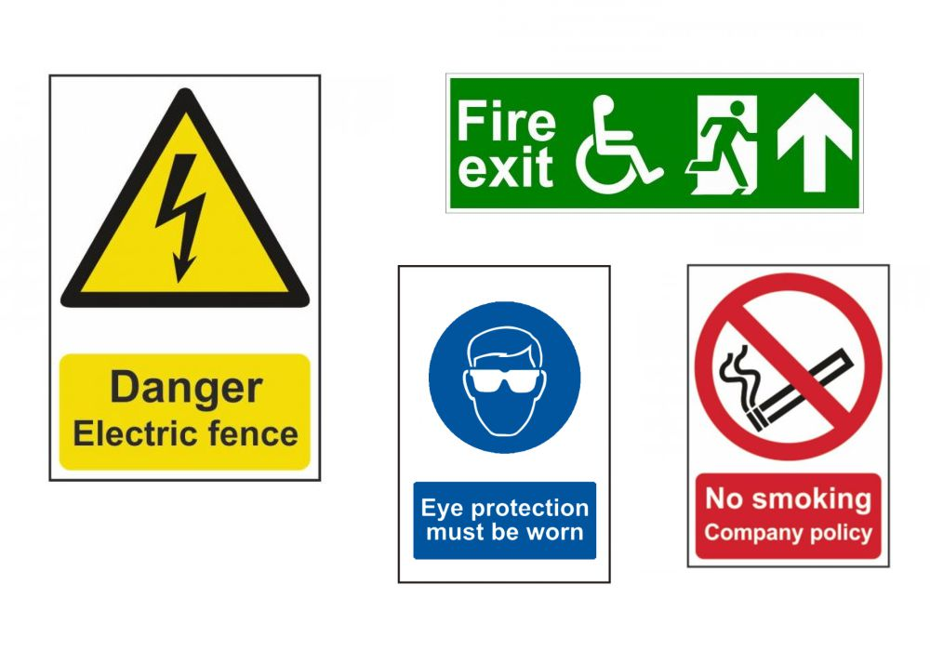

|  |
| --- |
| Remember: |

1. safety signs are only effective if you understand what they mean; if you do not understand a sign you should speak with management for training.

2. Safety signs must be visible. Do not place materials in the way or obstruct visibility. If you need to cover a sign, even temporarily, you should speak with management.

3. Check for safety signs when entering the site and at the start of every shift. New hazards may have been introduced to the area or the location of emergency equipment or the fire assembly point may have changed.

4. Ensure you wear all personal protective equipment (PPE) as identified on the mandatory signs on site.

5. You should comply with safety signs as failure to do so could lead to putting you or others at risk as well as you facing disciplinary action.

6. If you introduce a new hazard to the area ensure you display the appropriate signage as required, so you can warn others of the hazard.