|  |  |
| --- | --- |
| Reason: | Unsafe stacking of materials can lead to collapse and life changing injuries. |
| Outline: | This talk covers general points on stacking bricks, timber, pipes, and prefabricated panels. |

|  |
| --- |
| Stacking: |

1. When handling materials, wear work gloves and safety boots.

2. Only stack material in authorised areas; never near doorways, accessways or on fire escape routes.

3. Stack on level, firm surfaces and place on pallets or timbers.

4. Never make stacks higher than 3 times the minimum base width.

5. Stack materials close to the working area to reduce the amount of handling.

6. Keep your hands clear of the load if materials are being moved by machinery. Use tag lines if loads need to be controlled.

|  |
| --- |
| Bricks, Blocks and Palleted Material: |

1. Ensure the base of the stack is level. Only stack 2 packs high.

2. Ensure the upper pack is loaded squarely on to the lower one.

3. If banding is damaged or materials are displaced in the pack, do not stack other materials on top.

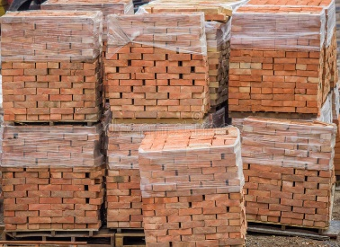 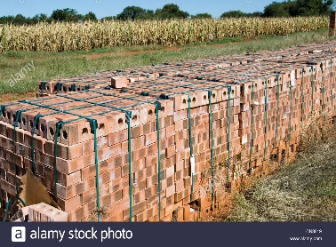 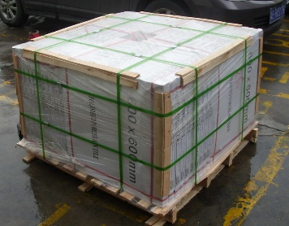

|  |
| --- |
| Timber: |

❶Racks are the best method of storing small-sized timbers.

❷Joists and larger timbers should be placed on bearers.

❸Do not stack vertically, leaning against other structures.

|  |
| --- |
| Large Prefabricated Panels: |

❶Stack flat or store secured in designed racks (stillages) and ensure items are secured with banding. Sheets of glass need to be stored individually.

❷Don’t lean against parts of semi-constructed buildings or temporary structures.

❸Don’t store upright in an area where panels could be affected by wind.

❹Secure if stored at height or in other exposed areas, especially lighter materials (such as insulation).

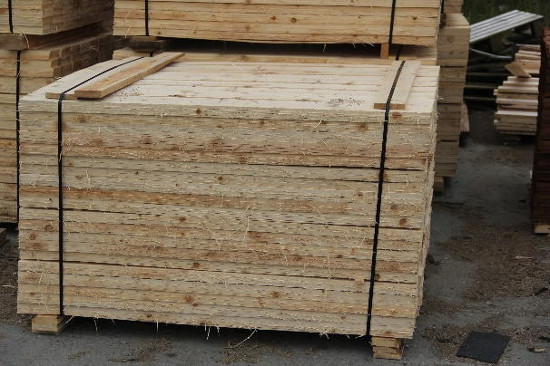 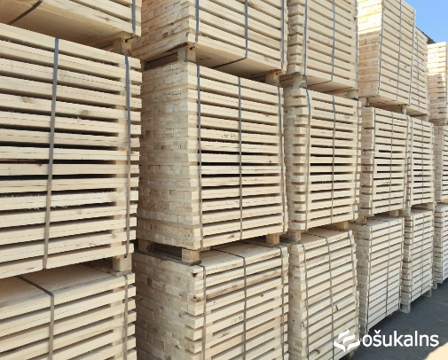

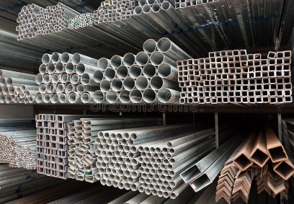 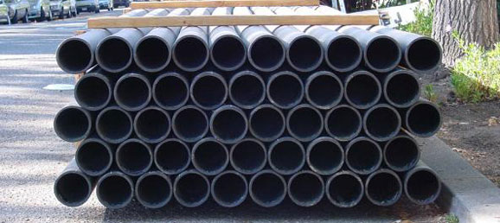

|  |
| --- |
| Pipes and Tubes: |

1. Where pipes are small in diameter stack in racks, if large in diameter securely chock at the base.

2. Don’t stack in pyramids as they can become unstable unless the pipes are banded.

3. Large concrete rings must be laid flat so that they cannot be moved or rolled by any person, especially children.

**Discussion Points:**

What sort of surface should materials be stacked on?

How high should packs of palleted blocks be stacked?

If a pack of blocks has damaged banding, what must you not do?

How should large timbers be stacked?

How can you prevent large pipes from rolling?