|  |  |
| --- | --- |
| Reason: | Every year many injuries occur through slips, trips & falls. Most of these injuries are easily preventable with a little care. |
| Outline: | This talk covers the causes and prevention of slips, trips & falls. |

|  |
| --- |
| Why do they occur? |

1. Most injuries from slips, trips and falls occur because of poor housekeeping.

2. Leaving items (such as cables, hand tools, rubbish, and surplus materials) on the ground will create trip hazards.

3. Spilt substances (such as oils & greases) will form a slip hazard if not immediately cleaned up.

4. General debris (such as brick and block fragments) can quickly accumulate and form a tripping hazard.

5. Trailing cables in the work area and across pedestrian routes are a frequent cause of tripping.

6. Mud on smooth surfaces (such as ladders or steps on vehicles) can cause a slipping and falling hazard.

7. Reduced levels of natural light (winter afternoons) can easily increase the tripping hazards if adequate access lighting is not provided. Tools, equipment, and materials that are visible in full daylight might be hidden in semi-darkness.

8. Potholes, changes in levels and uneven steps in the workplace can all lead to trips and falls.

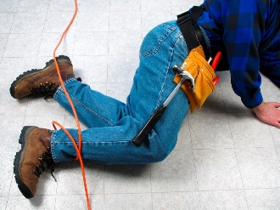 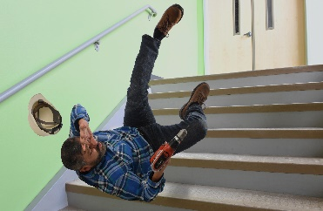 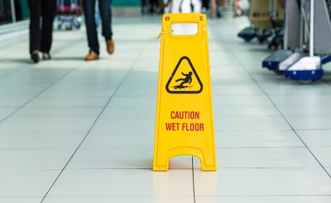

|  |
| --- |
| What you Must do: |

Clear up waste materials as you create them. Lightweight waste should be bagged or bundled, and nails removed from waste timber.

Work in a tidy manner; do not leave tools, equipment or unused materials lying about on the floor.

If you are using substances that could spill, ensure that you have a means of effectively clearing up the spillage.

Route cables for power tools above head height. If cables must be routed at floor level, try to avoid crossing pedestrian walkways.

Sites get muddy. Make sure boots and shoes are cleaned off before accessing plant equipment or climbing ladders. Do not spread mud by walking into clean areas.

Keep working areas clear of materials and tools where natural light levels may change throughout the day. Temporary lighting should be installed wherever lighting is inadequate.

Tell management if you do not have the right equipment to clear up and dispose of the waste you create.

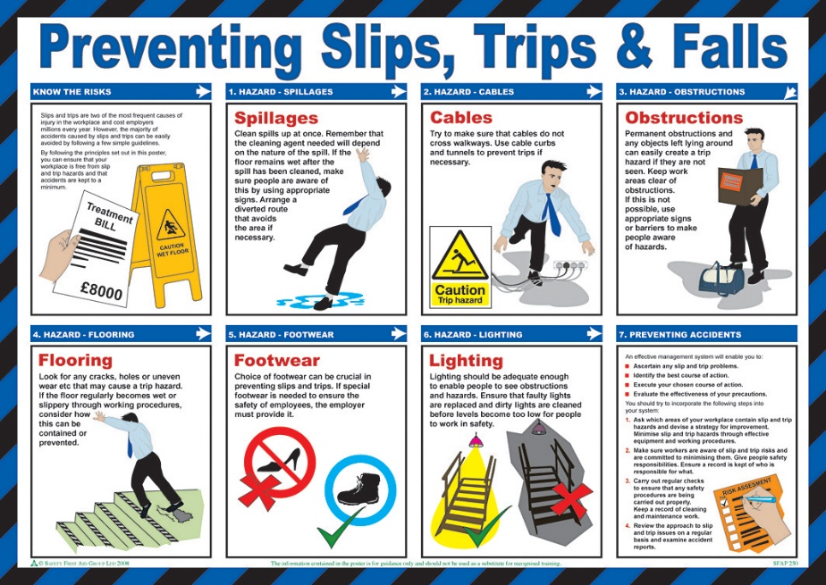

**Discussion Points:**

Why should cables be fixed above head height?

When should you clear up spillages?

What should you do before climbing a ladder?

What should you do if you notice tripping hazards on a pedestrian route?