|  |  |
| --- | --- |
| Reason: | Every year a significant proportion of all injuries at work are caused by manual handling. If you get it wrong today you will suffer the consequences tomorrow. |
| Outline: | This talk covers considerations and good techniques for manual handling. |

|  |
| --- |
| Considerations: |

❶Always use mechanical handling instead of a manual handling if possible. – Forklifts & pallet trucks.

❷Know your capabilities, only tackle jobs you can handle. Can you manage yourself or do you need help with the lift?

❸Is there a clear walkway with good lighting to the work area?

|  |
| --- |
| Checks to Carry out Before Lifting: |

* Always know the weight of the load before lifting.
* Wear gloves to protect against puncture wounds and cuts.
* Wear safety shoes or boots to protect from falling loads.
* Carry out a trial lift, get a feel for the size and weight of the item.

Simple aids like wheelbarrows reduce the risk of injury.

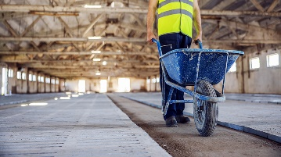

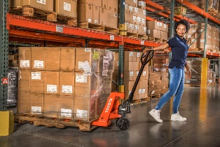

Use mechanical aids wherever possible – Pallet trucks.

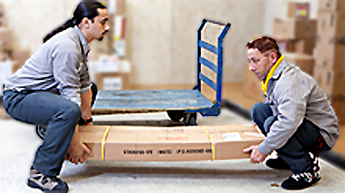

Some jobs can’t be done safely on your own. Seek assistance.

|  |
| --- |
| Good Handling Techniques: |

❶Stand reasonably close to the load, feet hip-width apart, one foot slightly forward pointing in the direction you’re going.

❷Bend your knees and keep your back straight (avoid stooping).

❸Get a secure grip on the load.

❹A good lifting technique uses the strong muscles in your legs.

❺Keep the load close to your body but don’t carry a load that obscures your vision.

❻Lift slowly and smoothly, avoiding jerky movements.

❼Avoid twisting your body when lifting or carrying a load.

❽When lifting to a height from the floor, do it in 2 stages if possible.

❾When 2 or more people lift a load, 1 person must give directions to co-ordinate the lift.

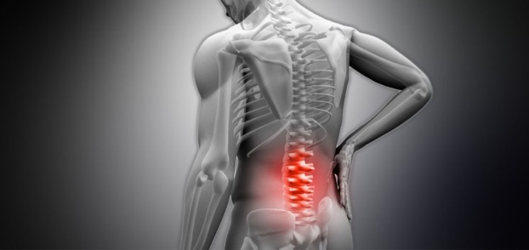

Back injuries can be permanent!

**Discussion Points:**

What checks should you carry out before lifting?

What PPE should you wear and why?

Describe how you would fit an object safely.

When 2 or more people are lifting a load, what should happen?

Name 2 hazards when lifting and carrying.

**REMEMBER: You only have 1 back so make sure to look after it!**