|  |  |
| --- | --- |
| Reason: | To protect workers from excessive exposure to hand-arm vibration at work. Prolonged exposure to hand-arm vibration can cause a range of symptoms, known as hand-arm vibration syndrome (HAVS). |
| Outline: | This talk covers the sources of hand-arm vibration in industry, and the steps that can be taken to reduce the risk. |

|  |
| --- |
| Effects from Hand-Arm Vibration: |

1. Prolonged exposure to hand-arm vibration can cause damage to blood vessels, nerves, tendons, ligaments, muscles, and bones.

2. Symptoms include tingling, pins and needles, loss of feeling in fingers, pain & throbbing in the fingers, loss of manual dexterity, painful joints and in particular pain when hands warm up after getting cold.

3. Carpel tunnel syndrome (CTS) is also caused by hand-arm vibration and causes severe nerve pains in the palm of the hands, which is often worse at night.

4. The effects of hand-arm vibration are often irreversible, causing sufferers pain and loss of amenity for the rest of their lives.

5. Victims are often unable to do up buttons, tie shoelaces or undertake many simple everyday tasks.

6. The symptoms may start as tingling in the hands but will develop and worsen with continued exposure to vibration.

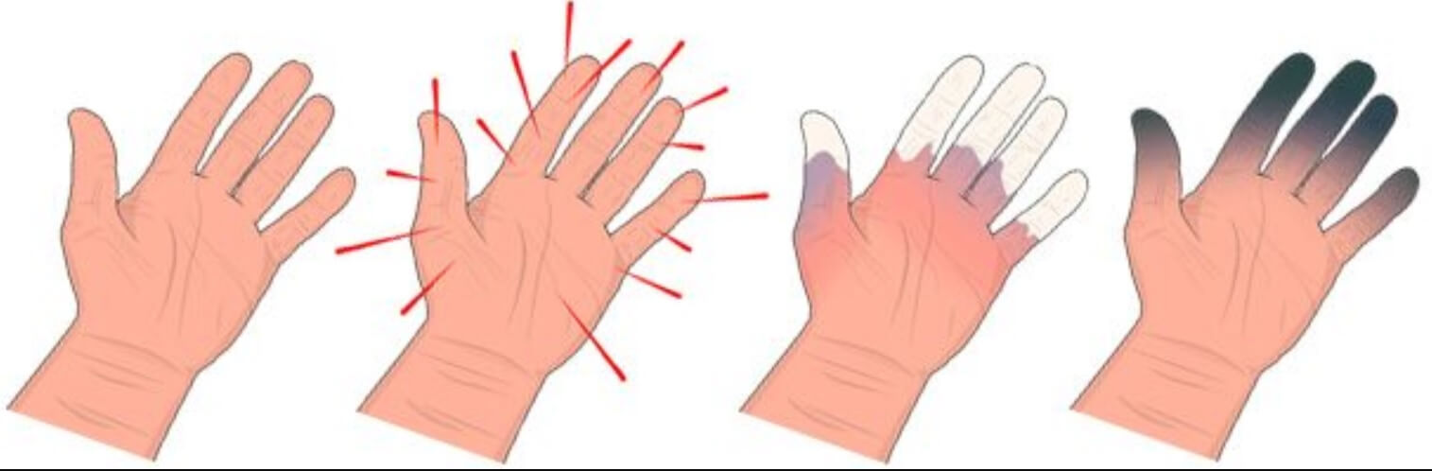

|  |
| --- |
| Sources of Hand-Arm Vibration: |

❶Hand-Arm vibration is generated by both rotating and percussive hand-held tools. Some tools (such as hammer drills) are both rotary and percussive.

❷Construction tools that generate significant levels of vibration include:

~Road & concrete breakers. ~Abrasive Wheels.

~Cut off saw or disc cutters. ~Power drills & chisels.

~Plate vibrators and scabblers. ~Concrete poker vibrators.

~Hammer drills. ~Chainsaws.

~Needle Guns. ~Angle Grinders.

~Riveters.

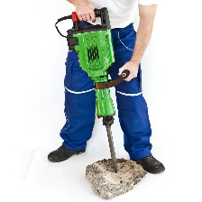 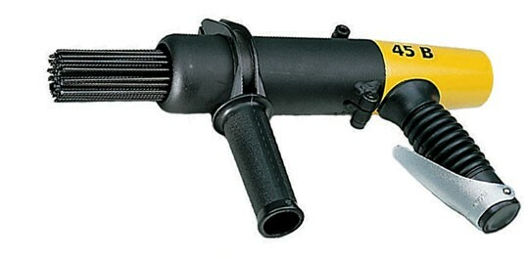 

|  |
| --- |
| How to Avoid Excessive Vibration Exposure: |

1. Employers should try to avoid the use of hand-held tools that generate vibration (e.g. by using an excavator-mounted breaker rather than hand-held breakers).

2. If it is not possible to avoid using hand-held tools, then low-vibration or vibration-reduced tools should be selected.

3. When using vibrating tools, it is important to take regular breaks. If working in a cold environment, warm your hands up and exercise your fingers during breaks.

**Take regular breaks!**

4. use a good technique when using hand-held tools – do not apply excessive force, let the tool do the work.

5. keep hands warm and dry, such as by wearing gloves. However, do not rely on anti-vibration gloves as they have very little effect on vibration.

6. if you experience any symptoms (such as pins & needles) tell management.

If you have been given trigger time limits for using vibrating tools, do not exceed them.

**Discussion Points:**

What vibrating hand-held tools have you used on sites you have worked on?

What should you do during breaks to reduce your risk of HAVS?

How can your exposure to hand-arm vibration be reduced?

What must you do if you think you are experiencing early symptoms of HAVS?