|  |  |
| --- | --- |
| Reason: | Noise-induced hearing loss is a common occupational health hazard. There is no satisfactory treatment for noise-induced hearing loss. |
| Outline: | This talk covers the hazards, controlling noise and ear protection. |

**When you’re Deaf, you stay Deaf!**

|  |
| --- |
| Hazards: |

1. Compressors, breakers, circular saws, generators, vibrating rollers and excavators, angle grinders, power saws and many other common pieces of equipment used in construction can generate potentially harmful levels of noise.

2. Even if you are not using the noisy piece of equipment, you could be affected by someone using it close by.

3. Exposure to extremely high noise levels will cause hearing damage in a shorter time than lower noise levels.

4. Ringing the ears or muffled hearing immediately after exposure are clear signs of excessively high noise levels.

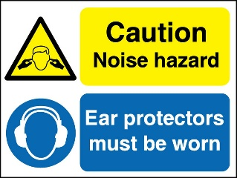 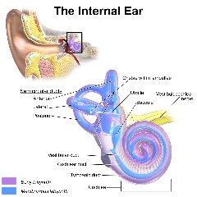

|  |
| --- |
| Controlling Noise: |

1. Keep as far away from noise sources as possible – don’t stand next to someone using a breaker unless you have to.

2. Use quieter equipment and work methods whenever you can (e.g., noise reducing saw blades will significantly reduce the noise from circular saws when block cutting).

3. Don’t leave machinery running unnecessarily and try not to expose others to your noise.

4. If possible, move the noise source away from the work area or move the work area away from the noise.

5. If possible, shield noisy processes; work behind sound-absorbing materials (such as spoil heaps).

6. Wear hearing protection when instructed to do so.

|  |
| --- |
| Ear Protection: |

1. Ensure earplugs are inserted correctly, as per the instructions.

2. If you are using disposable earplugs’ make sure you insert them correctly. Insert them by rolling them up and inserting them into your ear as far as you can while pulling the top of your ear upwards to open the ear canal.

3. Always insert earplugs with clean hands and dispose of them after each use.

4. Earmuffs and reusable earplugs should be cleaned regularly.

5. If earmuffs are used with the headband around the neck, the fabric head-strap must be used.

6. Inspect your earmuffs regularly – when the seals become worn, get them replaced.

7. Earplugs and earmuffs need to be selected carefully – If too effective, you may not be aware of things going on around you (such as plant movements) and that can be dangerous.

8. If you have problems wearing earplugs or earmuffs (such as significant discomfort) report this to your management.

9. Never wear earphones under earmuffs. You should not wear earphones when working on site in any case.

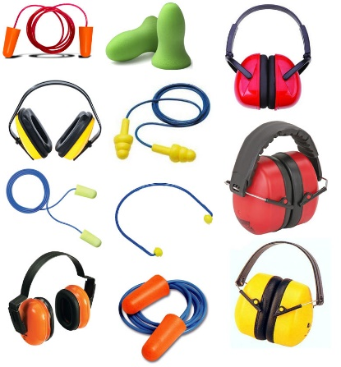

**Discussion Points:**

What significant sources of noise are you aware of in the workplace?

What should not be used instead of earplugs?

When should hearing protection be worn?

How can noise levels from plant and equipment be reduced?

How should you insert disposable earplugs?