|  |  |
| --- | --- |
| Reason: | Exposure to respiratory hazards (such as dusts, vapours, and fumes) must be prevented or controlled. Inhaling dusts, vapours or fumes can lead to both immediate and long-term health problems (such as breathing difficulties, asthma & cancer). |
| Outline: | This talk covers the main hazards from dusts, vapours, and fumes, and gives examples of control measures that should be taken. |

|  |
| --- |
| Sources of Dust and Fumes: |

❶Cutting, sanding, and grinding of construction materials will create harmful dust.

❷Welding and gas cutting of metals generates harmful fumes.

❸Work with old lead can expose you to lead oxide dust (white powdery deposits) which is also harmful.

❹Burning off old lead-based paints or heating lead creates harmful fumes.

❺Stripping out or other work involving fibrous insulation (such as asbestos or fibreglass insulation) will release harmful dust and fibres into the air.

|  |
| --- |
| Health Risks from Breathing in Dust or Fumes: |

1. Silica dust from cutting or scabbling concrete or cutting bricks or stone can cause lung disease (silicosis).

2. Dust from cutting or sanding hardwood (some softwoods) can cause nasal cancer.

3. Asbestos dust can cause cancer of the lungs or of the lining of the lungs & chest cavity.

4. Welding fumes can result in metal fume fever, which has flu-like symptoms.

5. Breathing in fumes from solvents and paint causes nausea, drowsiness, headaches and eventually unconsciousness and death in extreme cases.

6. Many substances create irritating dusts (such as fibreglass insulation materials). These should be regarded as hazardous.

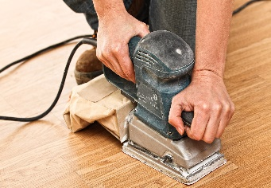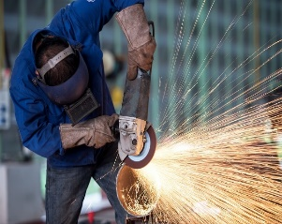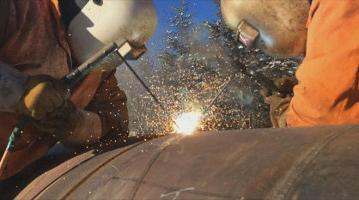

|  |
| --- |
| Precautions: |

❶Work should be planned to avoid the need for on-site cutting or other dust producing activities (e.g., cutting paving slabs).

❷If elimination is not possible, harmful dust and fumes must be controlled so they are not breathed in.

❸Where possible substances should be selected that do not give off harmful fumes and vapours (e.g., low solvent or solvent free paints).

❹Dust control techniques should be used, such as using plant and equipment with dust extraction devices or using water suppression.

❺If the company provides portable extraction equipment – Use it!

❻RPE will often be necessary, even when other dust control measures are apparent. Make sure you have the correct RPE for the substance, and that you know how to use it.

❼If you are issued with RPE, you will need a face-fit test.

❽Consider the effects that your work may have on other people.

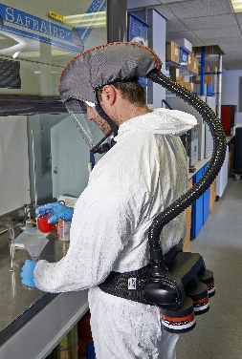 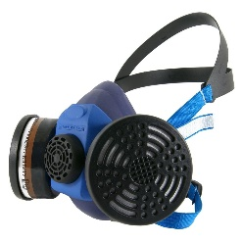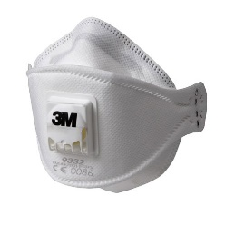

**Discussion Points:**

What work do you carry out that creates harmful dust or fumes?

What types of RPE are suitable for use with hazardous dust and fumes?

What is a face-fit test?

How do you inform others that you will be creating harmful dust or fumes?