|  |  |
| --- | --- |
| Reason: | Around 5000 people a year, from all industries, die from asbestos-related diseases. Asbestos kills more people in the UK than road traffic accidents. You need to be aware of the hazards of asbestos, where it could be found, and what you need to do. IT CAN KILL YOU! |
| Outline: | This talk covers what materials may contain asbestos, where it can be found and what you need to do to protect yourself. |

The asbestos industry estimates that over 3000 products contained asbestos. It can be found:

1. In insulation and sprayed coatings used for boilers, plant & pipework. Some are hidden in underfloor ducting, fire protection to steelwork, hidden behind false ceilings, thermal & acoustic insulation of buildings.

2. In insulating board used in fire protection to doors, protected exits & steelwork, claddings on walls & ceilings, internal walls, partitions & suspended ceiling tiles, fire blankets.

3. In asbestos cement, which is found as corrugated roofing & cladding sheets of building, flat sheets for partitions, cladding & other door facings, rainwater gutters & downpipes.

4. In other products, some textured coatings and paints, friction materials (such as brake linings & clutch plates), flashguards & components within equipment.

|  |
| --- |
| How Asbestos can Affect You: |

❶When asbestos-containing materials (ACMs) are disturbed, the fibres are released into the air and can easily be inhaled, ingested.

❷The fibres penetrate deep into the lungs where they remain leading to diseases such as asbestosis (fibrous scarring of the lungs), lung cancer, and mesothelioma (cancer of the lining of the lung). Mesothelioma is incurable and is always fatal.

❸Smoking increases the risk of asbestos related illnesses.

Almost all asbestos related deaths and ill health are a result to exposure that happened decades ago.

|  |
| --- |
| Hazardous Work: |

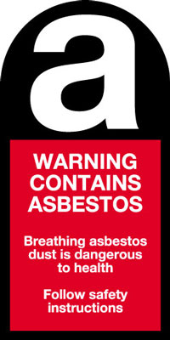

❶It is a legal requirement that workers who may be exposed to asbestos receive asbestos awareness training.

❷Anyone involved in building repair, maintenance and refurbishment is particularly at risk. It is estimated around 20 workers or former workers from the sector die each week in the UK.

❸Prior to any work in buildings built before the year 2000 that has potential to disturb ACMs, employers must ensure that a suitable survey is undertaken, and the work is planned to prevent exposure. This may involve removal of the ACMs, completed by a competent contractor licensed by the HSE.

❹make sure that you are given information regarding the possible presence of ACMs before working in any building built before the year 2000.

❺If you are not sure what material is, do not disturb it until you have found out. If you think that you have discovered ACMs, stop work immediately and advise management.

**Discussion Points:**

Where are you likely to find ACMs?

How can breathing in asbestos fibres affect you?

What do you need to know before you carry out work in existing buildings?

What should you do if you think you have discovered ACMs?

