|  |  |
| --- | --- |
| Reason: | Hazardous substances can be used in or created by various construction and industry processes. Using hazardous substances without proper controls in place can damage your health. |
| Outline: | This talk covers risk assessment, hazards, control measures and safe use of substances. |

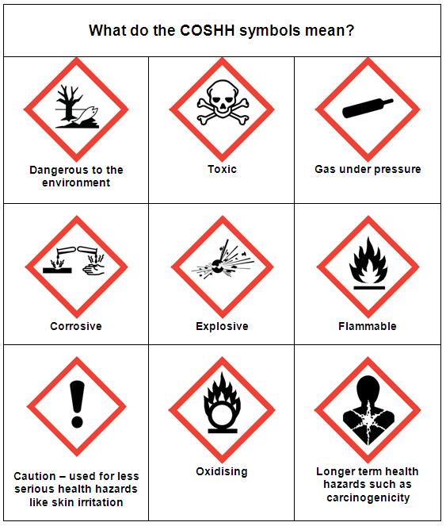

|  |
| --- |
| Risk Assessment: |

❶A competent person must carry out a risk assessment to decide whether:

~Exposure to a substance can be avoided.

~Alternative work methods can reduce exposure.

~A less hazardous substance can be used instead.

❷Many of the substances used in construction have the potential to cause harm.

|  |
| --- |
| Hazards: |

❶Your health could be affected by a hazardous substance through:

~Ingestion – Eating contaminated food.

~Inhalation – breathing in harmful dust or fumes.

~Injection – Sharp objects or high-pressure fluids.

❷Absorption – Chemicals entering through cuts.

❸Examples of hazardous substances in the workplace include:

~Contaminated ground ~Concrete admixtures ~Welding fumes

~Epoxy-based paints ~Cement ~Solvent Fumes

~Hardwood dust ~Resins ~Asbestos

❹Don’t mix chemicals or substances unless you are following a safe and authorised process.

❺Biological agents may also cause harm i.e., weils disease caught from contaminated water.

|  |
| --- |
| Control Measures: |

❶Follow your employers’ safe system of work and risk (COSHH) assessment for each substance.

❷When using hazardous substances, wear the correct PPE (where required).

❸Know how to look after and use your PPE correctly.

❹Ensure hazardous substances are put back into safe secure storage after use. Do not leave them on site.

|  |
| --- |
| Safe use of Substances: |

❶Make sure you are trained to use hazardous substances.

❷Comply with the Control of Substances Hazardous to Health (COSHH) assessment and the instructions on the product label and safety data sheet.

❸Don’t eat, drink or smoke when handling substances.

❹Don’t expose others to fumes, dust, gas, or other dangers from hazardous substances whilst you work.

❺Always wash your hands at the ned of each shift and before eating.

**Discussion Points:**

What can you wear to protect yourself against harmful substances?

Name 3 ways a substance can enter your body.

Where can you obtain information about a hazardous substance you are using?

Name 5 substances that you use in the workplace that are hazardous to health.