|  |  |
| --- | --- |
| Reason: | Inhalation of harmful dusts and fumes causes respiratory problems, which must be prevented. Harmful dusts cause health problems and long-term suffering. |
| Outline: | This talk covers aspects that require consideration when protecting against respiratory risks. |

|  |
| --- |
| Some Facts: |

* Approximately 3000 construction workers per year suffer from breathing and lung problems which are caused, or made worse, by their work.
* Approximately 5000 people die every year from asbestos related diseases, as a result of breathing in airborne asbestos fibres.
* More than 1 million working days a year are lost to work-related health in the construction industry.
* At any one time there are far more people off work through occupational ill health than there are because of work-related accidents.

|  |
| --- |
| Provision and Use: |

1. Where dust and fumes cannot be avoided by engineering or mechanical means (such as extraction, collection or dampening down) then the correct respiratory protective equipment (RPE) must be provided and used.

2. RPE must be designed to reduce the level of exposure to the type and quality of dust or fumes.

3. Different types of RPE are available, ranging from disposable, filtering half-masks and half-mask respirators with cartridges, to ventilated visors or helmet respirators.

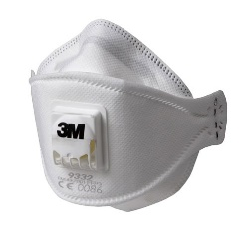 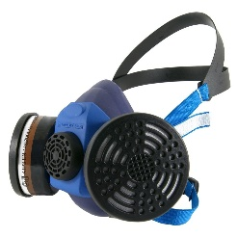 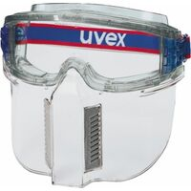 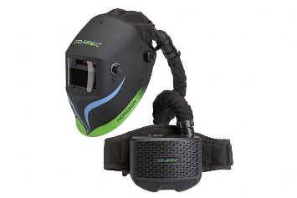

4. Selection of RPE is important and must consider people who wear glasses, have stubble & facial hair, or have long hair when it is not swept back and secured.

5. Personal face-fit is a critical element in the selection and use of RPE.

|  |
| --- |
| Your Duties as an Employee: |

1. Use RPE properly, wherever it is required.

2. Report any defects or damage to the RPE immediately.

3. Participate in any training or instruction provided RPE.

4. Inform your employer of any medical conditions that you have, which might be affected by the use of RPE.

|  |
| --- |
| Applications: |

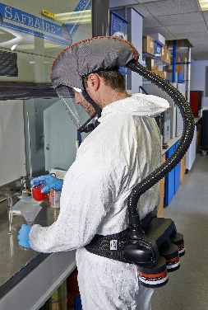 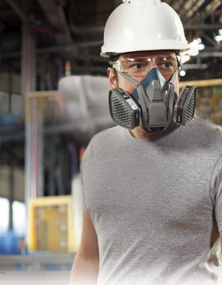 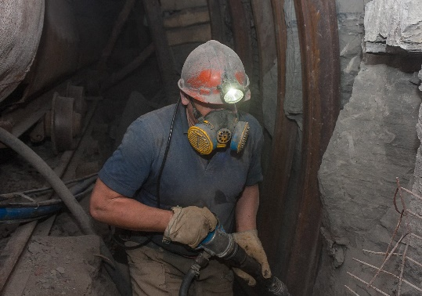

**Discussion Points:**

What should you think about, for yourself and others, in your work area if you are asked to carry out a task involving creating dust?

What is a face-fit test?

What should you do if your mask does not fit comfortable?