|  |  |
| --- | --- |
| Reason: | On average, 1000 eye injuries occur daily. 75% by impact, 10% by ingress of foreign bodies (e.g., dust) and 15% by burns or chemicals. The majority of these injuries can be prevented. |
| Outline: | This talk covers the hazards and the reasons for wearing eye protection. |

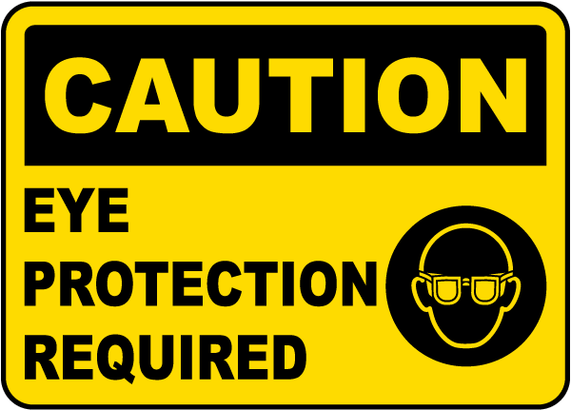 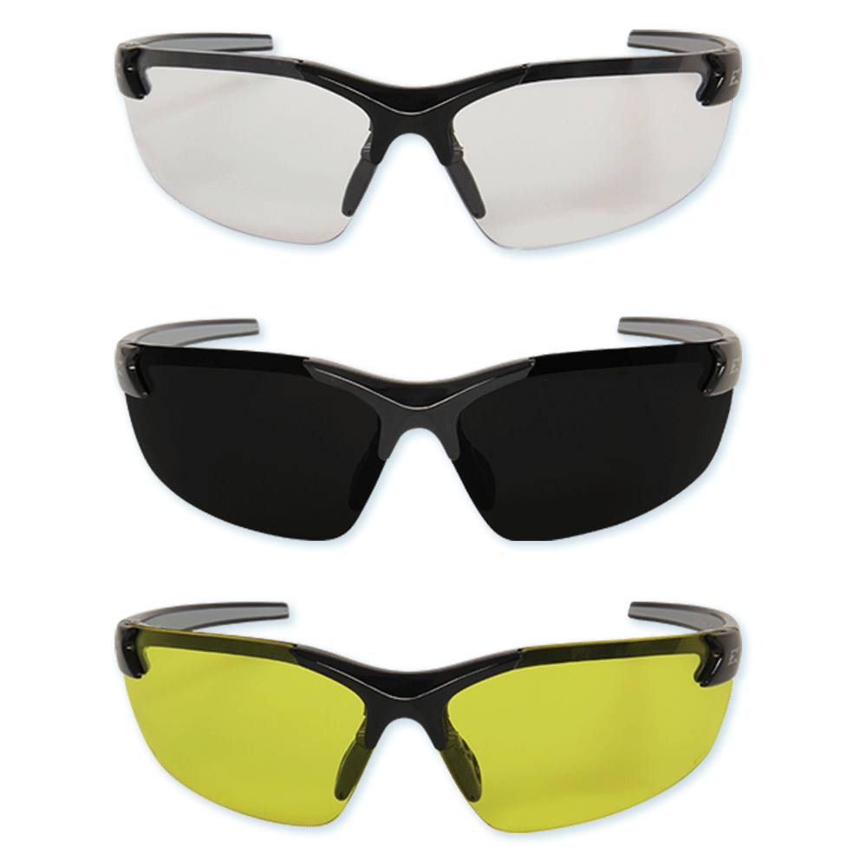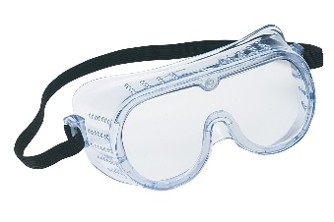 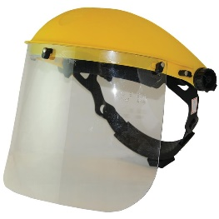

|  |
| --- |
| Possible Causes of Eye Injury |

* Using drills, hammers, chisels, or other percussive tools.
* Using compressed air and any gas, liquid, or vapour under pressure.
* Working with power tools where debris may be given off at speed (using abrasive wheels).
* Working with tools that will result in chippings being broken off (breakers).
* Welding, when ultraviolet light is given off that can damage eyes.
* Handling, or coming into contact with corrosive or irritant substances such as acids or alkalis.
* Handling and using cartridge-operated or compressed gas tools (nail gun).
* Cutting of wire or metal strapping that is under tension (such as brick bands).

|  |
| --- |
| Wearing Eye Protection: |

1. You have a legal obligation to use any eye protection provided.

2. Don’t go into areas where eye protection is required unless you are wearing it.

3. Ensure your eye protection fits you and is suitable for the job.

4. Ensure that any lost or damaged eye protection is replaced immediately; don’t be tempted to work without it.

5. Your eye protection should be appropriate for the job, comfortable to wear and kept clean.

6. there are several grades of eye protection, each to combat a different type of hazard. Only use the eye protection designated for the job you are doing.

7. All eye protection should carry a CE-mark to show it has been made to an industrial standard.

8. Take care of your eye protection when it is not being used and use a protective case.

9. Impact eye protection is available in different grades.

10. Refer to your risk assessment or ask your management for details on the type and grade of eye protection to be worn for the task.

**REMEMBER: Eye protection is replaceable; your eyes are not!**

|  |
| --- |
| Eye Injuries: |

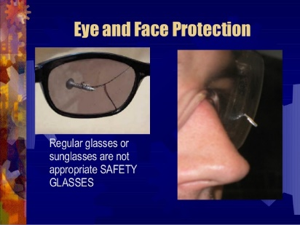 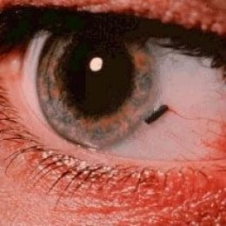 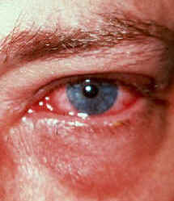

**Discussion Points:**

What should you do if you damage your eye protection?

How can welding affect unprotected eyes?

If you get something in your eye, what should you do?

What are the hazards of using a cut-off wheel?

What are the hazards associated with compressed air?