|  |  |
| --- | --- |
| Reason: | Some dangers arising from hazardous activities can be controlled, limited, risk reduced using effective personal protective equipment (PPE). |
| Outline: | This talk covers the measures necessary to ensure that the use of PPE is effective. |

|  |
| --- |
| What is PPE? |

1. PPE is equipment or clothing worn to protect the user from known hazards in the workplace.

2. In construction & industry, the most commonly worn items of PPE are high visibility clothing, safety boots, safety helmets & eye protection.

3. Other examples of PPE include ear defenders, respiratory equipment (RPE), safety harnesses and lanyards, protective gloves, and alternative clothing types.

|  |
| --- |
| Limitations: |

1. PPE will only protect the user.

2. It must be used in accordance with the manufacturers’ instructions and guidelines and any other training provided.

3. The actual level of effectiveness of PPE is difficult to assess as it depends on how well it fits the individual and if it is used correctly.

4. PPE must be in good condition and fit for purpose to be fully effective. Do not mistreat it, your health or life may depend upon it.

|  |
| --- |
| What we as an Employer must do: |

1. Asses the risks to your health and safety arising from your work activities.

2. Try to organise work activities so that PPE is not necessary as it should only be considered as a last resort.

3. Where PPE is necessary, select appropriate items that will suit the wearer but enable them to still be effective in their tasks.

4. Supply you with the necessary PPE free of charge.

5. Train you to use your PPE, explain its limitations and explain the implications of not using it.

6. Ensure capability if more than one item of PPE is worn.

7. Ensure PPE is maintained and replace defective or lost items at no cost to you as the employee.

|  |
| --- |
| What you as an Employee must do: |

1. Use PPE in accordance with instructions and training given.

2. Return PPE to storage, where provided after use.

3. Take reasonable care of your PPE and report its loss or any damage to your employer.

4. Never work without PPE when it is necessary.

|  |
| --- |
| Types of PPE: |

 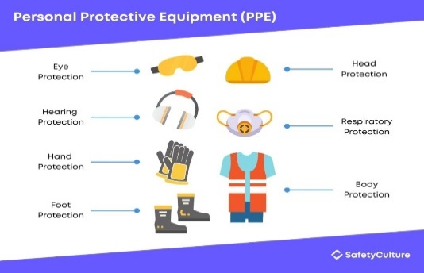

 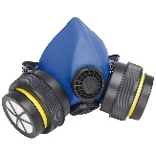  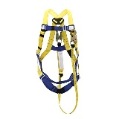 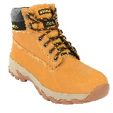

**Discussion Points:**

How much can your employer charge you for PPE?

What factors will determine the life of a safety helmet?

How do you think wearing PPE could increase the dangers to you?

What should you do if an item of your PPE is damaged?

Where should you store your PPE?