|  |  |
| --- | --- |
| Reason: | Statistics show that alcohol and drug use is increasing. This may lead to accidents/incidents in the workplace. |
| Outline: | This talk covers the effects of alcohol and drugs on your safety and the safety of others. |

In a high-risk industry such as ours, Alcohol, Drugs, and work do not mix!

They depress part of the brains functions which increases the

risk of an accident in the workplace.

|  |
| --- |
| Alcohol: |

1. Alcohol is a drug that depresses parts of the brain function. When working on site you need to be fully focused on the task in hand and be aware of your surroundings.

2. If you are found to be intoxicated with drink, you won’t be allowed to work and may well end up losing your job.

3. Don’t get drunk the night before and expect to work safely the following day, you may well still be over the legal limit for alcohol consumption, especially if driving to the workplace. It can take longer than you think to work its way out of your system.

Keep your head clear! – Leave alcohol for social events!

4. Many drivers who are killed in road accidents are over the legal blood alcohol limit.

5. A pint of 4% beer equals 2.4 units, taking roughly 1 hour for your liver to process one unit of alcohol.

6. 2 pints of strong lager or ale will put the average male over the legal limit.

7. Many workplace accidents have been alcohol related incidents.

  

|  |
| --- |
| Drugs: |

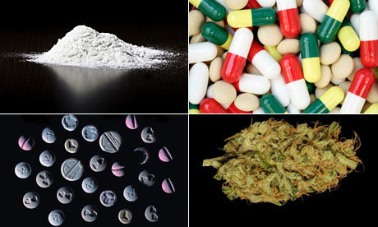

1. You are far more likely to have an accident on site when under the influence of drugs or legal highs.

2. You may feel that you do not have a drug problem, however if your or your colleagues get hurt, its everybody’s problem.

3. Drugs prescribed by your doctor could make you unfit for work, as can illegal drugs (including those commonly known as legal highs, which are illegal under the Psychoactive Substances Act 2016).

4. If you know somebody is under the influence, don’t think it isn’t your problem. Tell your management ASAP. Help stamp it out!

5. All drugs can affect your ability to perform workplace tasks correctly and in a safe manner.

6. Some effects of drugs are slow reaction times, clumsiness, poor decision making and distorted vision.

7. Signs to look out for:

Watery eyes, dilated pupils, running nose, constant sniffing, tight lips, sores, ulcers, trembling, fatigue, and irritability.

**Discussion Points:**

What effect can alcohol have on you?

What could be the result of being under the influence in the workplace?

If you took drugs, what effect could it have on your colleagues?

How long does a pint of beer take to get out of your system?

What should you do if you see a person taking drugs in the workplace?