|  |  |
| --- | --- |
| Reason: | Every workplace should have procedures in place for first aid. If you know first aid you could save a life. |
| Outline: | This talk explains what you should know, basic first aid and when it is required. |

**The priorities of First Aid are to:**

Save life, minimising the consequence of injury, prevent the deterioration of the casualty and to evacuate to medical help ASAP.

|  |
| --- |
| Before First Aid is Required: |

1. Ensure you know where the first aid kit is kept.

2. Know who the first aider(s) are, emergency first aider(s) and appointed persons are.

3. If you use anything from the first aid box ensure that it is replaced at a convenient time following the treatment.

4. Have a small first aid kit with you if you are working away from the main site or if you are using potentially dangerous tools and machinery. All SES Engineering (Newark) Ltd vans have a first aid kit on board.

5. Familiarise yourself with the procedure for contacting the emergency services.

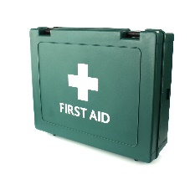 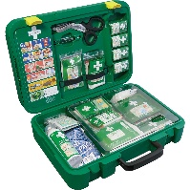 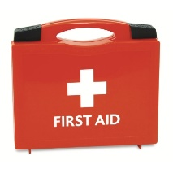

|  |
| --- |
| Discovering a casualty: |

1. Call or send someone for medical help and ensure your own safety as you approach the casualty. Do not put yourself at risk.

2. Remove any hazards from around the casualty, if safe to do so.

3. Don’t move the casualty unless they are in immediate danger.

4. Remain with the casualty, give reassurance (if conscious).

5. Don’t give drinks or food to the casualty. Only moisten their lips and don’t allow them to smoke, no matter how much they are begging with you!

6. Follow your first aid training should the casualty be unconscious, breathing or not breathing.

**IMPORTANT: STAY CALM.**

Do you know how to resuscitate and start the heart?

Do you know how to stop major bleeding?

Do you know how to treat scalds, burns and shock?

|  |
| --- |
| What we as an Employer are Expected to have done: |

Completed a first aid assessment.

Ensured that there is either an appointed person to take charge of first aid arrangements, or that there are appropriate numbers of suitably trained first aiders or emergency first aiders.

Ensured that there are adequate facilities and suitably stocked first aid kits.

Provided you with the information about first aid arrangements.

|  |
| --- |
| Employers Responsibilities: |

Ensure that first aid cover includes shift work and holiday cover.

Appoint somebody to check and restock first aid kits.

Ensure the first aid equipment provided is appropriate for the nature of the work environment, the number of workers, is in date and safe to use.

Ensure first aider(s) are easy to identify, known to all employees.

**EARLY HELP**

Call 999.

AED and expert help can be brought to the casualty.

**EARLY ADVANCED CARE**

Specialist treatment by paramedics and in hospital stabilises the casualty’s condition.

**EARLY DEFIBRILLATION**

A controlled electric shock from an AED is given to restore normal heart rhythm.

|  |
| --- |
| Chain of Survival: |

**Discussion Points:**

When finding a casualty, what is the first thing you should do?

What should you do until a first aider arrives?

Who is the first aider for the workplace?

What are the priorities of first aid?

**EARLY CPR**

Chest compressions and rescue breaths used to buy time until expert help arrives.