|  |  |
| --- | --- |
| Reason: | Prompt accident reporting and accurate accident investigation are important. Establishing why accidents occur and examining their effects can help prevent them from being repeated. |
| Outline: | This talk covers reporting and recording procedures. |

|  |
| --- |
| Causes of Accidents/Incidents: |

* People not thinking about what they are doing.
* People not following instructions.
* People not following the training they have been given.
* Unsafe manual handling, loading, stacking & storage.
* Overloading of workplaces i.e., scaffolding and hoists.
* Incorrect use of plant and other machinery.
* Using faulty or ‘bodged’ equipment.
* Illegal removal of guards and barriers.
* Failure to use PPE or use it incorrectly.
* Ignoring safety signals, signs, and warning devices.

|  |
| --- |
| The Cost of Accidents to You: |

* Pain, suffering and disability.
* Loss of earnings and extra expense due to disability.
* Unable to do your job or pursue leisure activities.
* Unable to support family, including possibly family break-up.
* Death. You won’t care, but your family and friends will.
* Someone is expecting you home tonight!

|  |
| --- |
| Accident/incident reporting: |

Health & safety law requires that the following types of accident be reported to the HSE:

1. Fatalities & specified injuries.
2. Injuries resulting in more than 7 days off work (LTI - Lost Time Injury).
3. Occupational diseases.
4. Dangerous occurrences.

Unsafe conditions and near misses should always be reported to management.

Be receiving such accident reports the HSE and the company can establish accident trends, highlight areas of weakness, and effectively target preventative measures.

Everyone on site must ensure that all accidents, no matter how minor, are recorded in the workplace accident book.

Completed accident reports are confidential.

If accurate records are made, the affected parties can refer to them later, if there is a need.

Accidents to members of the public arising out of site activities must be reported.

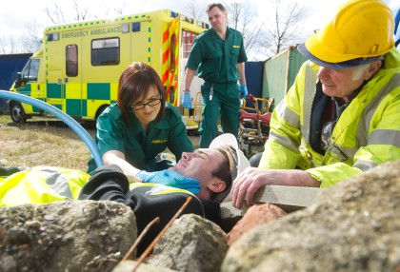 

|  |
| --- |
| Accident Investigation: |

We as an employer have a duty to investigate all accidents to establish the cause and prevent recurrence.

The HSE and the police will also investigate fatalities and other serious incidents.

If you are involved in an investigation:

1. Listen carefully to the questions and remain calm.
2. State honestly what you saw or heard.
3. Do not be afraid to say when you do not know an answer.

Remember that the reason for the investigation is to prevent the accident happening again, not to place blame.

**Discussion Points:**

What action should you take if you witnessed and accident?

Why is it important that all accidents are recorded in the accident book?

Why is it important to report unsafe conditions and near misses?

Who should be informed at SES Engineering (Newark) Ltd if an accident has just occurred?

Why is it important to fully co-operate with someone who is carrying out and accident investigation?